**Product Marketing & Selling Portal**

## A PROJECT REPORT

*Submitted by*

## Misha Thakkar: 5079

**Name of Company**: Gateway Group Of Companies

**Date of Submission**: 23-July-2020

**Submitted To**

**K. S. School of Business Management**

M.Sc. – Computer Application and Information Technology



**Index**

|  |  |  |  |  |  |
| --- | --- | --- | --- | --- | --- |
| Sr.No | Name of Topic | | | | Page Number |
|  | Title | | | | I |
|  | Certificate | | | | II |
|  | Acknowledgements | | | | III |
|  | List of Figures | | | |  |
|  | List of Tables | | | |  |
|  | Table of Contents | | | |  |
| Chapter 1 | Introduction | | | | 5 |
|  | 1.1 | Organization Profile | | 5 | |
|  | 1.2 | System Details | | 5 | |
|  |  | 1.2.1 | Existing System | 5 | |
|  |  | 1.2.2 | Proposed System | 5 | |
|  | 1.3 | Scope | | 5 | |
|  | 1.4 | Objectives | | 6 | |
| Chapter 2 | Proposed System Requirement Gathering | | | | 7 |
|  | 2.1 | Stackholder of System | | 8 | |
|  | 2.2 | Requirement Gathering Technique Used | | 11 | |
|  | 2.3 | Consolidated List of Requirement | | 12 | |
|  | 2.4 | Project Definition | | 12 | |
| Chapter 3 | System Management and Planning | | | | 14 |
|  | 3.1 | Feasibility Study | | 14 | |
|  |  | 3.1.1 | Technical | 14 | |
|  |  | 3.1.2 | Economical | 14 | |
|  |  | 3.1.3 | Operational | 14 | |
|  | 3.2 | Hardware –Software Requirement | | 15 | |
|  | 3.3 | System Panning | | 15 | |
|  |  | 3.3.1 | Work Breakdown Structure | 16 | |
|  |  | 3.3.2 | GANTT chart | 17 | |
|  | 3.4 | Process model | | 18 | |
| Chapter 4 | System Analysis and design | | | | 20 |
|  | 4.1 | UML(Unified Modeling Language) | | 20 | |
|  | 4.2 | System Flow Diagram | | 34 | |
|  | 4.3 | Data Dictionary | | 36 | |
|  | 4.4 | User Interface | | 43 | |
|  | 4.5 | System Navigation | | 44 | |
| Chapter 5 |  | Input Output Design | | 46 | |
| Chapter 6 |  | System Testing | | 66 | |
| Chapter 7 | 7.1  7.2  7.3 | Summary Assumptios Limitation  Future Scope  Bibliography | | 71 | |

**List of figures**

|  |  |  |
| --- | --- | --- |
| Sr.no | Figures | Page Number |
| 1 | 3.3.1 Work Breakdown Structure | 12 |
| 2 | 3.3.2 Gantt Chart | 13 |
| 3 | 3.4 Incremental model | 14 |
| 4 | 4.1.1 Use case – Visitor | 16 |
| 5 | 4.1.2 Use case – User | 17 |
| 6 | 4.1.3 Use case - Admin | 18 |
| 7 | 4.1.4 Activity Diagram – Visitor | 20 |
| 8 | 4.1.5 Activity Diagram – User | 21 |
| 9 | 4.1.6 Activity Diagram – Admin | 22 |
| 10 | 4.1.7 Sequence Diagram – Visitor | 24 |
| 11 | 4.1.8 Sequence Diagram – User | 25 |
| 12 | 4.2.9 Sequence Diagram – Admin | 26 |
| 13 | 4.3.7 Database diagram | 35 |
| 14 | 4.2 System Flow Diagram –Visitor | 28 |
| 15 | 4.2 System Flow Diagram-User | 28 |
| 16 | 4.2 System Flow Diagram –Admin | 28 |
| 17 | 4.3System Navigation  4.4Front End Design   * 1. Report Design | 40 |

Acknowledgments

It was a great experience working on the documentation of “Product Marketing and Selling Portal”.

We express our gratitude towards those who were constantly involved with us during our project.

The phenomenon remains same that no project ever can be executed proficiently and efficiently

without sharing the meticulous ideas, technical expertise and innovative thoughts put

forwarded by technical and non-technical veterans.

Whenever a technical project is developed, eventually it requires conductive technical

environment and technical guidance to get involved in the assigned project enthusiastically.

We also grateful to “KSSBM” for being extremely friendly and cooperative during entire

course of our project report. Their continuous help and support made the project docum

entation much easy. There is no exact word to express our regards and legitimate gratitude

to one of our esteemed techno personality, without them this project could not get an

entrance towards the execution. Our Project mentor is the pioneer who availed this

magnificent option to us to move ahead.

**CHAPTER 1 : INTRODUCTION**

* 1. **ORGANIZATION PROFILE**

The Gateway Corp, a privately held global enterprise, is headquartered in India and The Netherlands. The Gateway Corp is the principal holding company and promoter of all Gateway Group Companies, comprising of 20 independent operating companies across 16 countries.

Over the last 22 years of Technology excellence, the Group has etched an enviable record of 80% client retention, in some of the most complex, non-English speaking markets, where we ensure that technology remains at the forefront of our clients’ business to achieve strategic differential advantage over their competition.

Our Vision 2023 is built on this foundation. The aggressive strategy for organic and inorganic growth entails – development of disruptive solutions, strategic initiatives & partnership and new markets penetration.

|  |  |
| --- | --- |
| **Company Name** | The Gateway Group of Companies |
| **Company Address** | B/81, Corporate House, Judges Bunglow Road, Bodakdev, Ahmedabad, Gujarat 380054 |
| **Company Established** | 1997 |
| **Contact Person** | Vandita Dhariya |
| **Contact no** | 8527221753 |
| **Website** | <https://thegatewaycorp.com/> |
| **Services** | Solution Consulting  Digital Transformation  IT Services  Products & Platforms |

* 1. **SYSTEM DETAILS**

## STUDY OF CURRENT SYSTEM

There are only few web portals available which provides functionality as our web application. One of the best advantage of our portal is product purchasement security, manually verified buyers & sellers and 100% secured buyer’s & seller’s information (Like order details, personal details, user’s cart details etc.).

## PROBLEMS AND WEAKNESS OF CURRENT SYSTEM

* Current systems do not support return and replacement of products.
* Current systems do not provide functionality to cancel pre-requested orders.
* Current systems do not support payment gateway for product purchasement.
* Current systems do not provide functionality to share product details to others.
* Current systems do not provide user contact/complaint forum.
  1. **SCOPE OF SYSTEM**
     + Create and manage different users with varied roles and scopes for admin.
     + Create and manage products details for admin.
     + Create and manage locations details for admin.
     + Create and manage categories details for admin.
     + Create and manage events details for admin.
     + Create and manage user’s cart products for admin.
     + Manage add new product requests for admin.
     + Manage add new event requests for admin.
     + Manage product purchase requests for admin.
     + Create and manage all server configuration for admin
     + Manage error logs and user interaction logs for admin
     + Manage product purchase status for admin.
     + Promote (Request to Add) Own Product for login user and guest.
     + Request to add new Event for login users and guest.
  2. **OBJECTIVES**

Product Marketing and Selling Portal is E-Commerce Portal written in C# language,.NET MVC framework based which supports promoting and selling a product to a customer also it is defined as being the intermediary function between product development and product selling. It provides facility to users for select the product according to their choice of category and location. Main objective of our portal is to enable time management, secure transaction without data loses and making easy system that people can easily find their product information which they want.

# **CHAPTER :2 PROPOSED SYSTEM REQUIREMENT GATHERING**

**2.1 STACKHOLDER OF SYSTEM**

### **Admin**

* Manage user regarding roles, user accessibility and system configurations.
* Manage application data regarding product, categories, locations and events details.
* Manage requests regarding add new product, add new event and purchase products.
* Manage product purchasement status and user verification(manually).
* Admin has full access to check app logs and reports of user access.
* Admin can manage user regarding roles, user accessibility and system configurations.
* Admin can manage application data regarding product, categories, locations and events details.
* Admin can manage requests regarding add new product, add new event and purchase products.
* Admin can manage product purchasement status and user verification.
* Admin has full access to check app logs and reports of user access

### **Login User**

* Login User can add product to cart and purchase product according to their choice of category and location from portal.
* Login User can request to add new product and also can request to add new event.
* Login User can also check status of requested for purchase a product.
* Registered User can add product to cart and purchase product according to their choice of category and location from portal.
* Registered User can request to add new product and also can request to add new event.
* Registered User can check status of requested for purchase a product.

### **Guest User**

* Guest User can add product to cart and can interact with portal like login user except purchasing products. To purchase product guest user must be register self.
* Guest User can request to add new product and also can request to add new event.

### **SYSTEM REQUIREMENTS**

* 1. **Login**

**I/P:** Email and Password

**Process:** Match email and password with stored database

**O/P:** If credentials match than user is redirected to dashboard

### **Admin**

* + 1. **Create/Manage Products I/P:** Product details

**Process:** Store details in database

**O/P:** Success or failure message

* + 1. **Create/Manage Registered Users I/P:** Registered User details **Process:** Store details in database **O/P:** Success or failure message
    2. **Create/Manage Product Categories I/P:** Category details

**Process:** Store details in database

**O/P:** Success or failure message

* + 1. **Create/Manage Product Locations I/P:** Location details

**Process:** Store details in database

**O/P:** Success or failure message

* + 1. **Create/Manage Events I/P:** Event details

**Process:** Store details in database

**O/P:** Success or failure message

* + 1. **Manage Product Purchasement Requests I/P:** Product Purchasement details **Process:** Store details in database

**O/P:** Success or failure message

* + 1. **Manage Add Product Requests I/P:** Product details

**Process:** Store details in database

**O/P:** Success or failure message

### **Manage Add Event Requests**

**I/P:** Event details

**Process:** Store details in database

**O/P:** Success or failure message

* + 1. **Manage Product Purchasement Status I/P:** Product Purchasement details **Process:** Store details in database

**O/P:** Success or failure message and reflect into purchasement status

* + 1. **Manage User Verification (Manually) I/P:** Event details

**Process:** Store details in database and manually verify user details

**O/P:** Success or failure message

* + 1. **Manage System Settings I/P:** System settings

**Process:** Update system setting configurations

**O/P:** Success or failure message

* + 1. **Manage Logs and Reports I/P:** Start date and end date

**Process:** generate report from database

**O/P:** Report and logs for admin in txt file

### **R.3: Registered User**

* + 1. **Purchase Product According to their choice of Categories and Locations**

**I/P:** Product details

**Process:** Check product available or not in database

**O/P:** Success or failure message

### **Add Product to Cart According to their choice of Categories and Locations**

**I/P:** Product details

**Process:** Store details in database

**O/P:** Success or failure message

### **Promote Own Product (request to add new product) into Portal I/P: Product details**

**Process:** Store details in database and verify product details by admin

**O/P:** Success or failure message

* + 1. **Request to Add New Event into Portal I/P:** Event Details

**Process:** Store details in database and verify event details by admin

**O/P:** Success or failure message

* + 1. **Check Status of requested to Purchase Product I/P:** Product Purchasement Status

**Process:** Check product purchasement status into database and reflect into user product purchasement status

**O/P:** Product Purchasement Status

### **Visitor(Guest) User**

* + 1. **Add Product to Cart According to their choice of Categories and Locations**

**I/P:** Product details

**Process:** Store details in database

**O/P:** Success or failure message

* + 1. **Promote Own Product (request to add new product) into Portal I/P:** Product and User details

**Process:** Store details in database and verify product details by admin

**O/P:** Success or failure message

* + 1. **Request to Add New Event into Portal I/P:** Event and User Details

**Process:** Store details in database and verify event details by admin

**O/P:** Success or failure message

## FEATURES OF NEW SYSTEM

* + - Easy to use
    - Reliable
    - Time saving
    - Secure

## USER CHARACTERISTICS

* + - **Admin: -** Admin can manage roles, user scopes, product details, categories details, location details, event details, product purchasement requests, add product requests, add event requests, product purchasement status, manual user verification, configure settings, can see logs and reports.
    - **Login User: -** Login user can interact with portal, purchase product according to their choice of category and location. Login user can request to promote own product (add own product), request to add new event and also continuously check status of requested for purchase a product.
    - **Guest User: -** Guest user can also interact with portal like login user except purchasing products. To purchase product guest user must be register self. Guest user can request to promote own product (add own product) and request to add new event also.
  1. **PROJECT DEFINITION**
* Product marketing & selling portal is web based application. Product marketing is a process of promoting and selling a product to a customer also it is defined as being the intermediary function between product development and product selling. This web application provides the facility to users for select the product according to their choice of category and location. User can only buy the product if he/she is registered user and also User can promote own product into portal.
* Product marketing & Selling Portal is a process of promoting and selling a product to a customer also it is defined as being the intermediary function between product development and product selling. This web application provides the facility to users for select the product according to their choice of category and location. User can only purchase the product if he/she is registered user and also user can promote own product into portal.it includes three modules: Admin, Login(Registered) User and Guest User.

## PURPOSE

The main purpose of this project is to build the web application that enable the time management, secure transaction without data loses and making easy system that people can easily find their product information which they want. From the any place they can find the product according to their requirement they can search the category and location and get the data related their requirement. Manage Product marketing selling process. The time of User will be saved and user details are secured.

* + - It helps to user to get products according to their requirement.
    - It is not complex system.it is user friendly system.
    - User can purchase the product if they are registered user.
    - All Users can request to add own product for selling purpose and that request is monitored by Admin
    - All Users can do request for add event and that request is monitored by Admin.
    - Admin can manage the product purchase request, add product request and add event request.
    - Admin can add, update and delete products, categories, locations and events.

**CHAPTER 3: SYSTEM MANAGEMENT AND PLANNING**

* 1. **FEASIBLITY STUDY**

Whatever we think need not be feasible .It is wise to think about the feasibility of any problem we undertake. Feasibility is the study of impact, which happens in the organization by the development of a system. The impact can be either positive or negative. When the positives nominate the negatives, then the system is considered feasible.

The main objective of the feasibility study is to test the Technical, Operational and Economical feasibility for adding new modules and debugging old running system. There are aspects in the feasibility study portion of the preliminary investigation:

3.1.1 Technical Feasibility:-

* + - The technical feasibility study focuses on how you will deliver a product or service how you will deliver a product or service through which technology?
    - The current system developed is technically feasible.
    - It is a web based user interface. Thus it provides an easy access to the users.
    - To access the system, internet connectivity is must require, because it is web Based websites.

# 3.1.2 Economical Feasibility:-

* + - Economic feasibility is based on cost and be benefits.
    - The cost of hardware and software for the class of application being considered.
    - The benefits in the form of reduced costs of fewer costly errors.
    - The cost if nothing change (i.e. the proposed system is not developed).
    - We are using the open source platform to build our system.
    - Thus, the project is economically feasible for both client and us.

3.1.3 Operational feasibility:-

* + - Operational feasibility states how the requirements are satisfied and also provides possible solutions.
    - By doing so there is no need for the company either to recruit some special individual to run the system or spend a huge amount to train some individual.
    - Thus, the project is operationally individual.
    - This project well-planned design would ensure the optimal utilization of the resources and would help in the improvement of performance status.
  1. **HARDWARE-SOFTWARE REQUIRMENT**

### **3.2.1 HARDWARE REQUIREMENTS**

* + - * Microsoft Windows 7/8/10 installed computer.
      * At least 4 GB of RAM.
      * At least 1 GB of hard disc space.

### **3.2.2 SOFTWARE REQUIREMENTS**

* + - * Visual studio Community 2017
      * SQL server 2017
      * IIS Server
      * Web browser (Chrome/Explorer/Mozilla Firefox)

* 1. **SYSTEM PLANNING**
     1. **WORK BREAKDOWN STRUCTURE**

### What is a work breakdown structure?

Simply put, a work breakdown structure is a hierarchical decomposition of the scope/work that needs to be estimated and executed during the course of the project in order to accomplish the project objectives and deliverables.

**WORK BREAKDOWN STRUCTURE**



1 PMSP

1.1.1 Stack Holder of System

1.3.1 UML Diagrams

1.4.1 Code Construction and Review

1.6.1 Service

Requirement Gathering Techniques

Finalize Requirement List

1.3.2 System Flow Charts

1.6.2 Facility

1.3.3 Data Dictionary

1.6.3 Feedback

1.1.4 Project Definition1.3.4 User Interface

1.3.5 System Navigation

1.2 Project Management & Planning

1.2.1 Feasibility Study

1.5.1 Development Testing

H/w S/w Requirement1.5.2 Operational Testing

Project Management and planning

Process Model

1.5 Testing

1.6 Maintains & Support

1.4 Coding

1.3 Analysis & Design

1.1 Requirement Gathering

### **3.3.2** **PROJECT SCHEDULING CHART**

|  |  |  |  |  |
| --- | --- | --- | --- | --- |
| **No** | **TASK NAME** | **START**  **DATE** | **FINISH**  **DATE** | **DURATION** |
| 1 | Feasibility  study | 27/01/2020 | 01/02/2020 | 1 week |
| 2 | Requirement Gathering and Analysis on gathered  requirements | 03/02/2020 | 15/02/2020 | 2 weeks |
| 3 | Designing | 17/02/2020 | 29/02/2020 | 2 weeks |
| 4 | Core Coding | 02/03/2020 | 14/03/2020 | 2 weeks |
| 5 | Actual Coding | 16/03/2020 | 28/03/2020 | 2 weeks |
| 6 | Testing and  Maintenance | 30/03/2020 | 13/04/2020 | 2 week |
| 7 | Documentation | 13/04/2020 | 20/04/2020 | 1 week |

* 1. **PROCESS MODEL**
* The process model is a core diagram in structured analysis and design. Each process Transforms inputs into outputs.
* In order to complete our project in total of ten months duration, what we should do exactly is following the analysis, design, and implementation and testing parts one by one and in each one of these parts returning the previous ones and do some modifications where necessary. What we need is definitely the characteristics of the incremental model.

**Incremental Model**

* The incremental model combines elements of the linear sequential model (applied Repetitively), with the iterative philosophy of prototyping. Incremental Model is combination of one or more Waterfall Models. In Incremental Model, Project requirements are divided into multiple modules and each module is developed separately. Finally developed modules are integrated with other modules. During development of each module, waterfall model is followed for each module development separately and passes through the requirements, design, implementation and testing phases.
* The series of releases is referred to as “increments”, with each increment providing more Functionality to the customers. After the first increment, a core product is delivered, which can already be used by the customer. Based on customer feedback, a plan is developed for the next increments, and modifications are made accordingly and this process continues until product is delivered.
* Early increments can be implemented with fewer people. If core product is well received, then additional staff can be added to implement the next increment.
* We increments earlier to the main increment are called as “stripped down” versions of the final product.
* If there are less number of employees to work on the project Incremental development model is very useful to complete the project before the deadline. In a project early increments can be done with less number of people. In case if the core product is well-defined and understood more employees can be added if needed in the future increments.
* One of the benefits of Incremental process model is that it can be planned to manage technical risks.
* Diagram of Incremental Process Model:

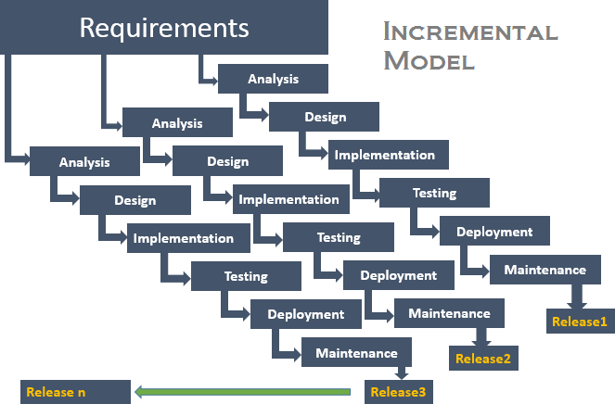

Steps:

These tasks are common to all the models

Planning: required as many people (software teams) work on the same project but different function at same time.

1. Modeling: involves Analysis and Design.
2. Construction: this involves the implementation (coding) & testing.
3. Deployment: integration of all the increments.

**CHAPTER:4 SYSTEM ANALYSIS and DESIGN**

* 1. **UML Diagram**

The Unified Modelling Language is standard visual modelling language intended to be used for :

* + - Modelling business and similar processes,
    - Analysis, design and implementation of software-based systems

UML can be applied to diverse application domains(e.g. banking, finance, internet, aerospace, healthcare, etc.) It can be used with all major object and component software development methods and for various implementation.

* + 1. **Use case Diagram**
* To model a system, the most important aspect is to capture the dynamic behaviour. Dynamic behaviour means the behaviour of the system when it is running/operating.
* Only static behaviour is not sufficient to model a system rather dynamic behaviour is more important than static behaviour. In UML, there are five diagrams available to model the dynamic nature and use case diagram is one of them.
* Now as we have to discuss that the use case diagram is dynamic in nature, there should be some internal or external factors for making the interaction.
* These internal and external agents are known as actors. Use case diagrams consists of actors, use cases and their relationships. The diagram is used to model the system/subsystem of an application. A single use case diagram captures a particular functionality of a system.
* Hence to model the entire system, a number of use case diagrams are used.
* In brief, the purposes of use case diagrams can be said to be as follows :
* Used to gather the requirements of a system.
* Used to get an outside view of a system.
* Identify the external and internal factors influencing the system.
* Show the interaction among the requirements are actors.

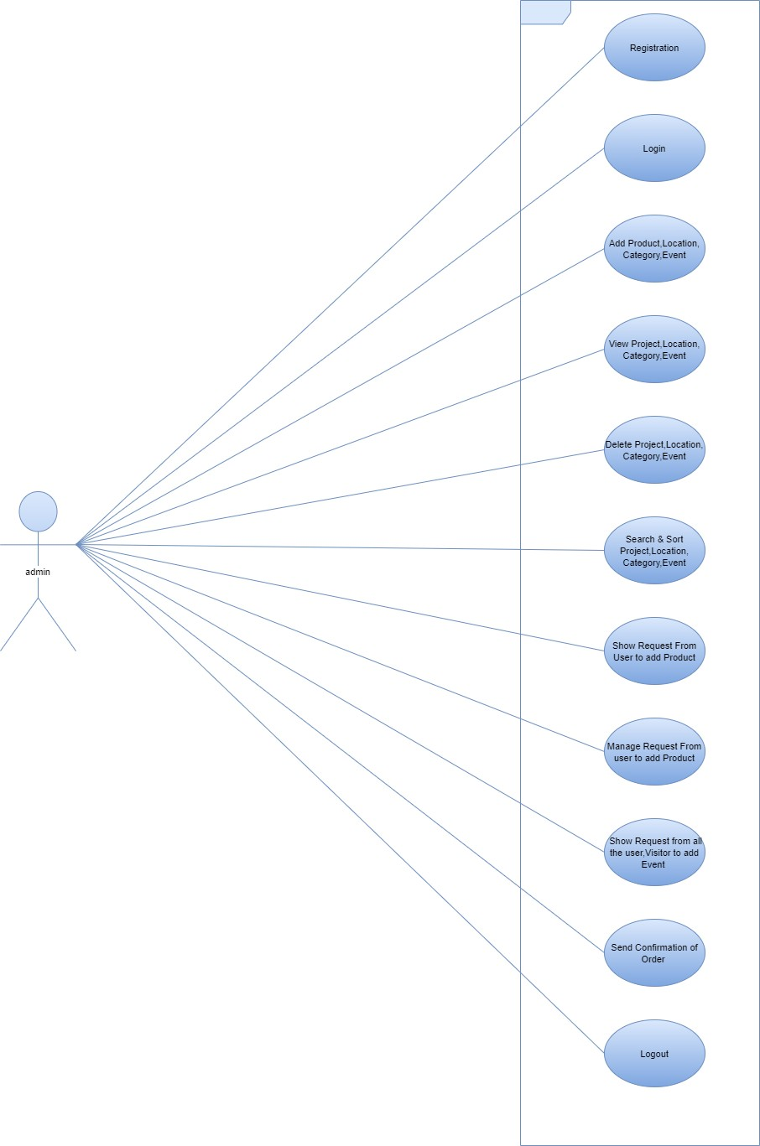

Figure 4.1 Use Case Diagram for Admin

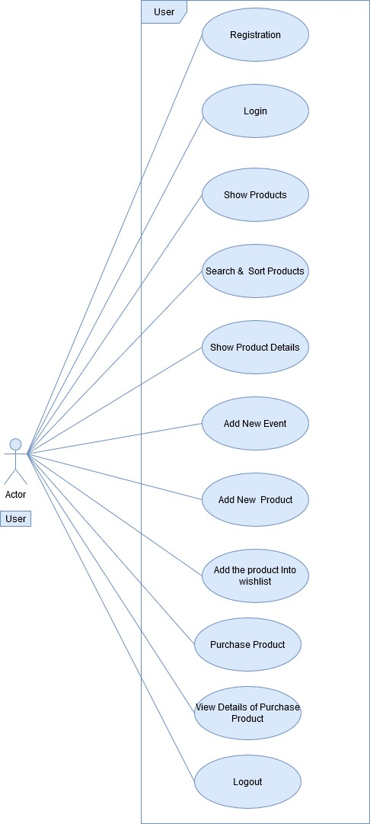

Figure 4.2 Use Case Diagram for Registered User

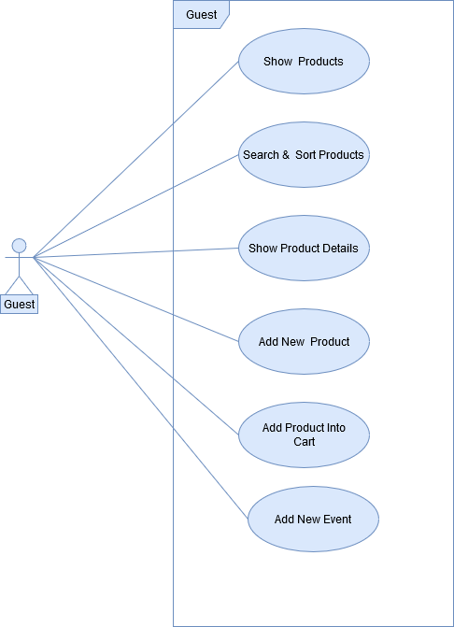

Figure 4.3 Use Case Diagram for Visitor (Guest User)

* + 1. **Activity Diagram**
* Activity diagrams are graphical representations of workflows of stepwise activities and actions with support for choice, iteration and concurrency. In the Unified Modelling Language, activity diagrams are intended to model both computational and organizational processes
* Activity diagram is another important diagram in UML to describe the dynamic aspects of the system.
* Activity diagram is basically a flowchart to represent the flow from one activity to another activity. The activity can be described as an operation of the system.
* The control flow is drawn from one operation to another. This flow can be sequential, branched, or concurrent. Activity diagrams deal with all type of flow control by using different elements such as fork, join, etc.
* The purpose of an activity diagram can be described as −
* Draw the activity flow of a system.
* Describe the sequence from one activity to another.
* Describe the parallel, branched and concurrent flow of the system.

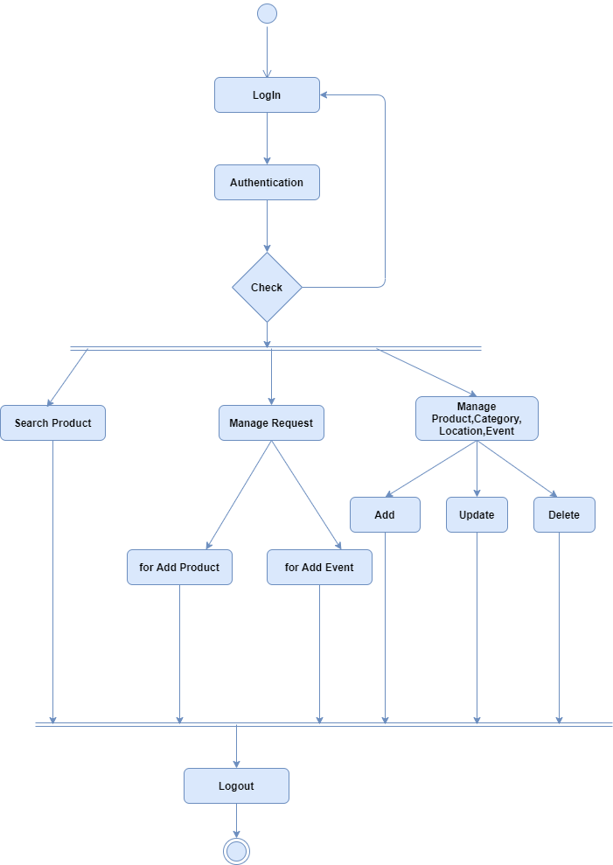

Figure 4.4 Activity of Admin

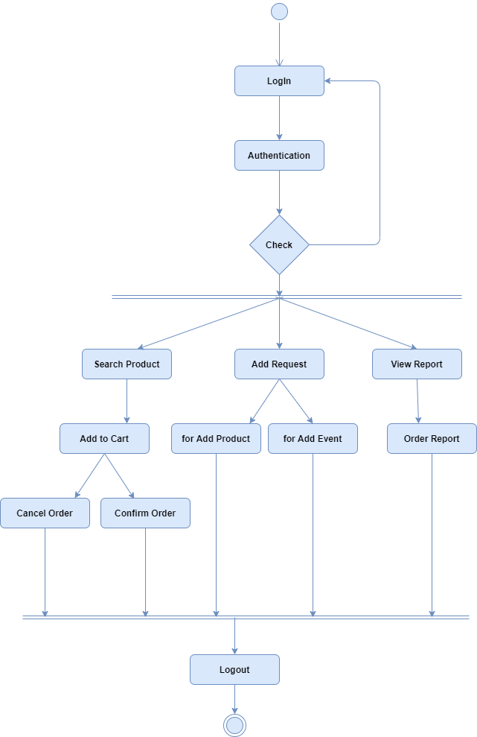

Figure 4.5 Activity of Registered User

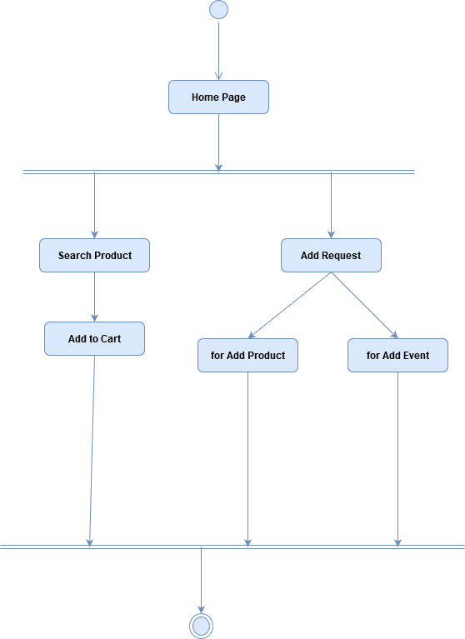

Figure 4.6 Activity of Visitor (Guest) User

* + 1. **Sequence Diagram:**

A sequence diagram is an interaction diagram that shows how objects operate with one another and in what order. It is a construct of a message sequence chart.

A sequence diagram shows object interactions arranged in time sequence. It depicts the objects and classes involved in the scenario and the sequence of messages exchanged between the objects needed to carry out the functionality of the scenario. Sequence diagrams are typically associated with use case realizations in the Logical View of the system under development. Sequence diagrams are sometimes called event diagrams or event scenarios.

A sequence diagram shows, as parallel vertical lines (lifelines), different processes or objects that live simultaneously, and, as horizontal arrows, the messages exchanged between them, in the order in which they occur. This allows the specification of simple runtime scenarios in a graphical manner.

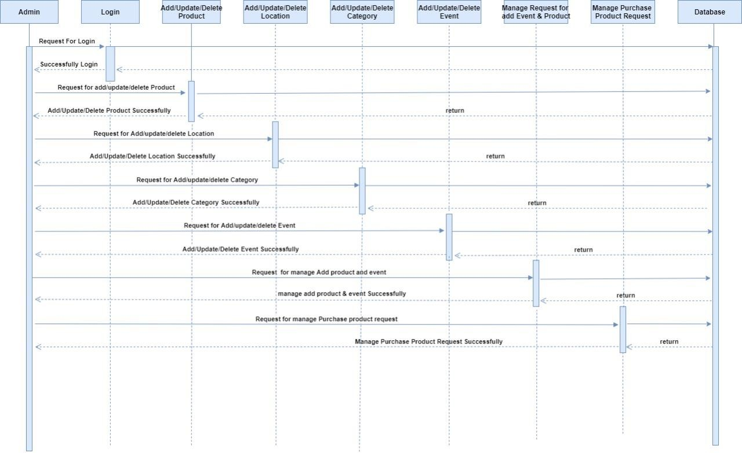4.7Sequence diagram for Admin

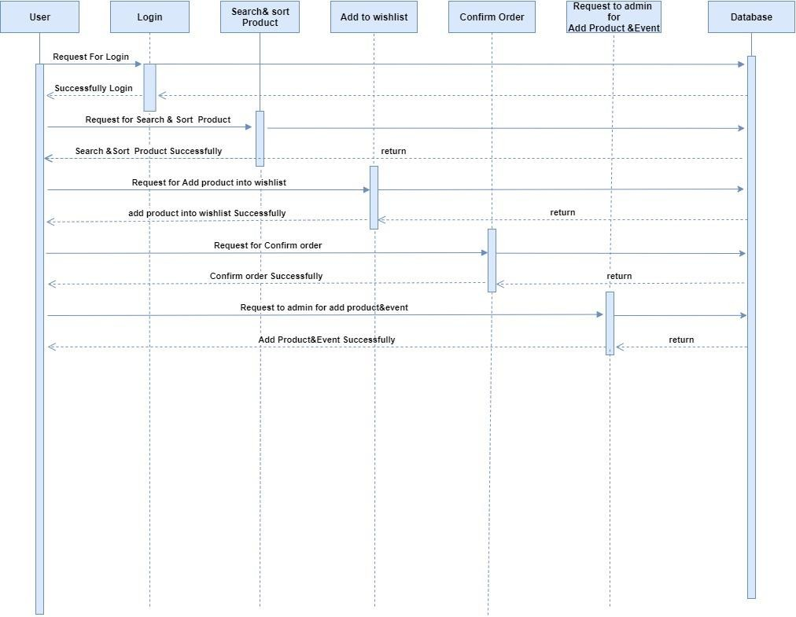

4.8 Sequence diagram for Registered User

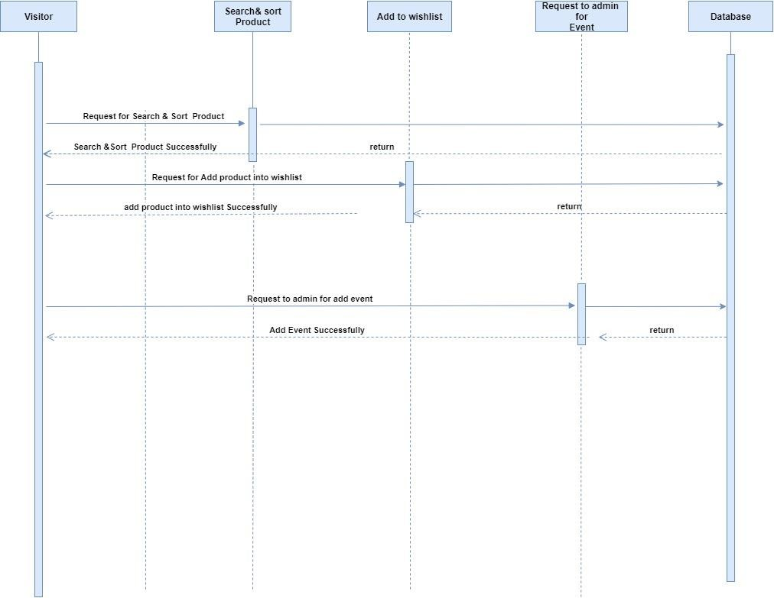

4.9 Sequence diagram for Visitor (Guest) User

**4.1.2 Systemflow Diagram**

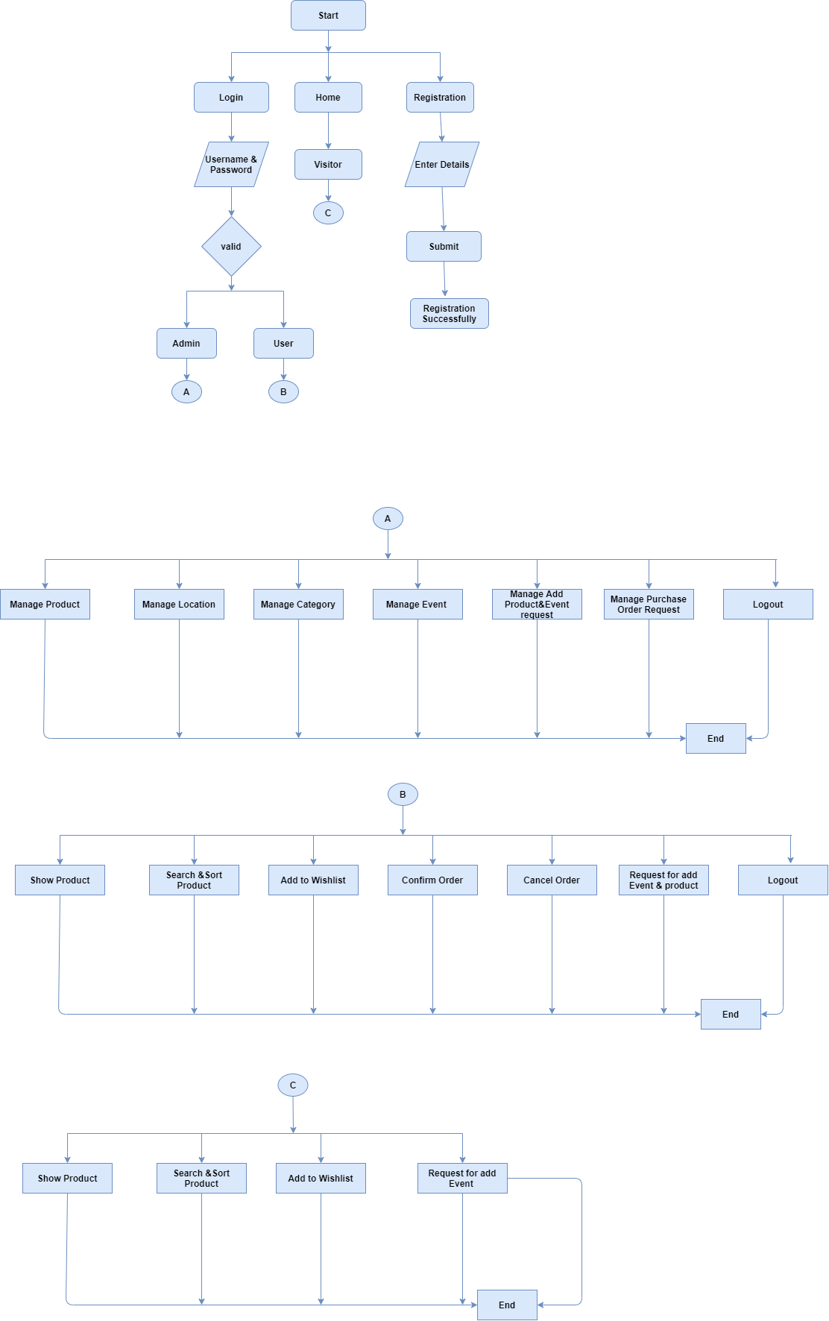

4.10 System Flow Diagram

* 1. **Data Dictionary**

**“**A **Data Dictionary** is a catalogue of elements in the system.**”** These elements centre on the data

and they structured to meet user requirements and organization needs, the major elements are data flows, data stores and processes. The Data dictionary stores the details and description of these elements.

### Why Data Dictionary is important?

* To manage the details in large systems.
* To communicate a common meaning for all system elements.
* To documents the failure of the system.
* To facilitate analysis of the details in order to evaluate characteristics and determine where the system changes should be made.
* To locate errors and omission in system.

### What does Data Dictionary record?

The Data Dictionary contains two types of description for all data following through system

### Data Elements

* + Data Description
  + Aliases
  + Length
  + Data values

### Data Structure

* + Sequence Relationship
  + Selection Relationship

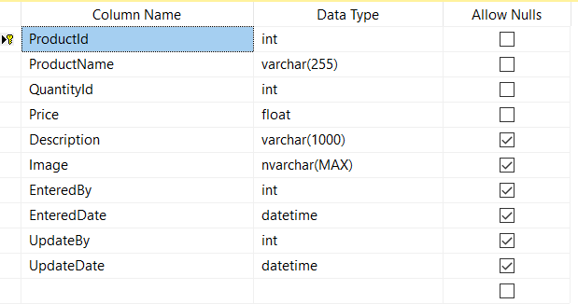

Figure tbl-1.Product Data Dictionary

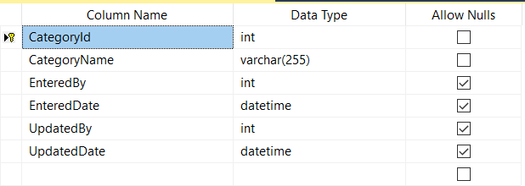

Tbl 2 Category Data Dictionary

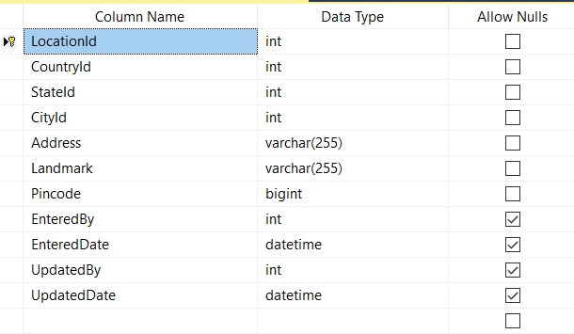

Tbl-3 Location Data Dictionary

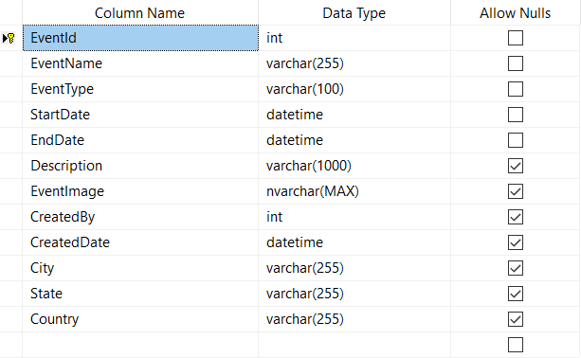

tbl-4 Event Data Dictionary

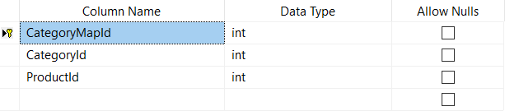

Tbl-5 Product-Category Map Data Dictionary

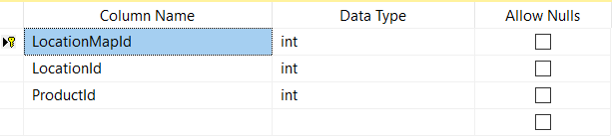

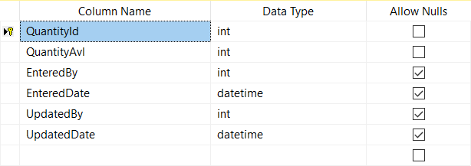Tbl-6 Product-Location Map Data Dictionary

Tbl-7 Product-Quantity Data Dictionary

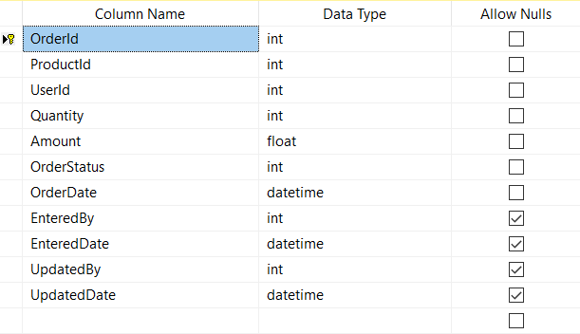

Tbl-8 Order Details Data Dictionary

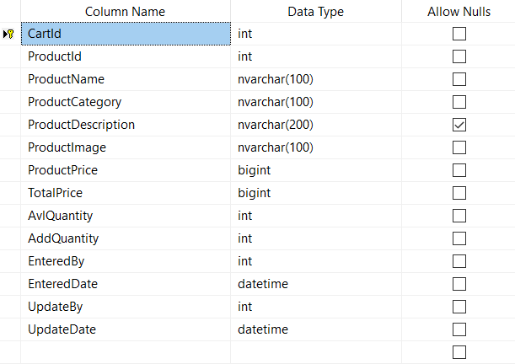Tbl-9 Product-Cart Details Data Dictionary

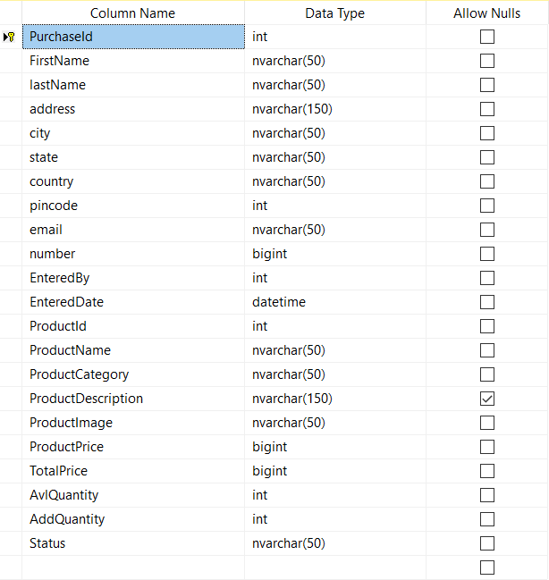

Tbl-10 Product-Checkout Details Data Dictionary

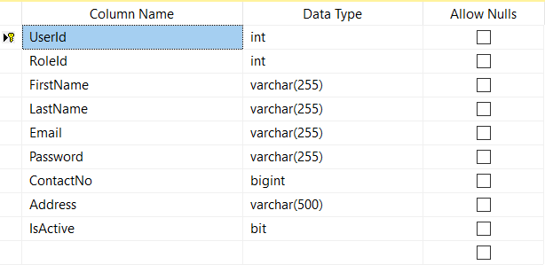

Tbl-11 User Details Data Dictionary

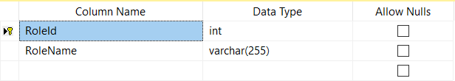

Tbl-12 User-Roles Data Dictionary

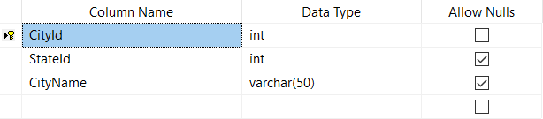

Tbl­-13 Location-City Details Data Dictionary

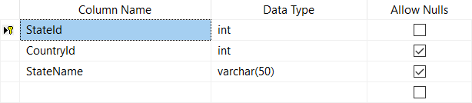

Tbl-14 Location-State Details Data Dictionary

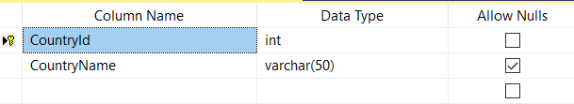

Tbl-15 Location-Country Details Data Dictionary

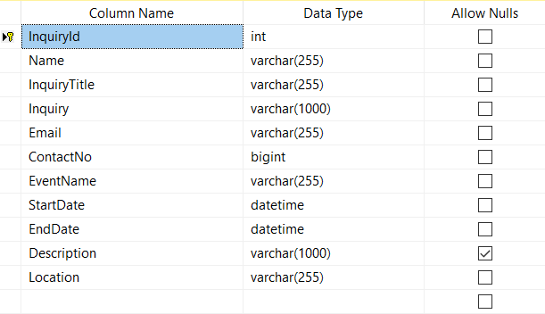

Tbl-16 Event-Inquiry Data Dictionary

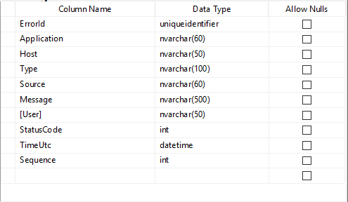

Tbl-17 Error Log Data Dictionary

* + 1. **Database Diagram**
       - Class diagram is a static diagram. It represents the static view of an application. Class diagram is not only used for visualizing, describing, and documenting different aspects of a system but also for constructing executable code of the software application.
       - Class diagram describes the attributes and operations of a class and also the constraints imposed on the system. The class diagrams are widely used in the modelling of object oriented systems because they are the only UML diagrams, which can be mapped directly with object-oriented languages.
       - Class diagram shows a collection of classes, interfaces, associations, collaborations, and constraints. It is also known as a structural diagram.
       - The purpose of the class diagram can be summarized as −
* Analysis and design of the static view of an application.
* Describe responsibilities of a system.
* Base for component and deployment diagrams.

Forward and reverse engineering

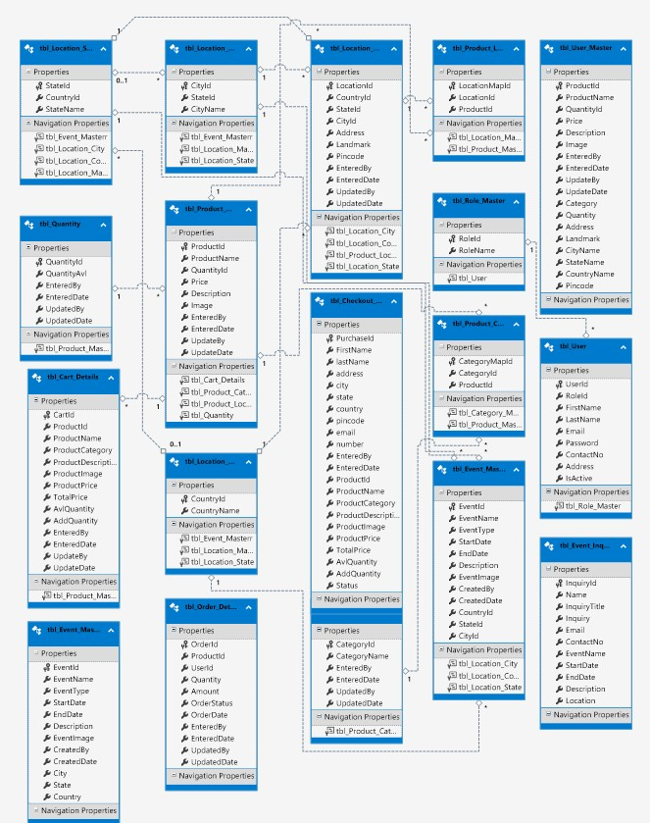4.11Table Relation Sche

* 1. **System Navigation**

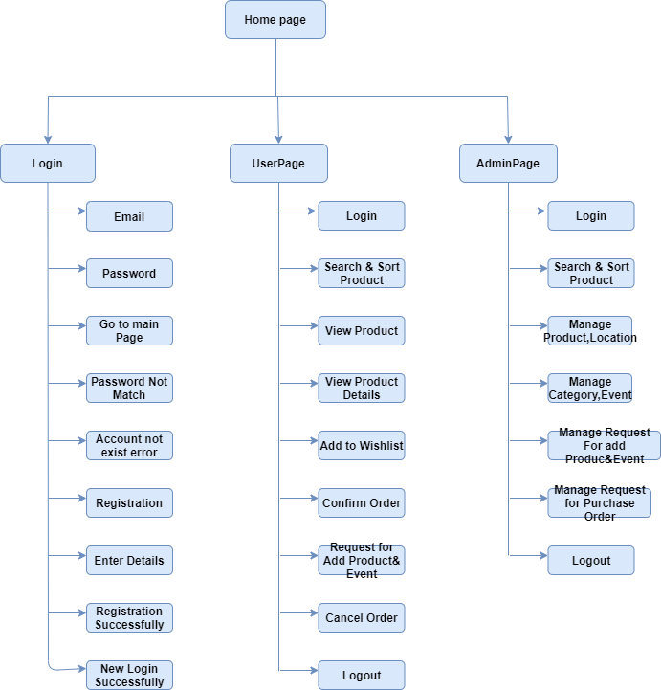

4.12System Navigation Diagram

**CHAPTER – 5 –Input Output Design**

* A user guide or user's guide, also commonly known as a manual, is a technical communication document intended to give assistance to people using a particular system. It is usually written by a technical writer, although user guides are written by programmers, product or project managers, or other technical staff, particularly in smaller companies.
* User guides are most commonly associated with electronic goods, web portals, computer hardware and software.
* Our user guides contain both a written guide and the associated images. In the case of our application, it is usual to include screenshots of how the program should look. The language used is matched to the intended audience.

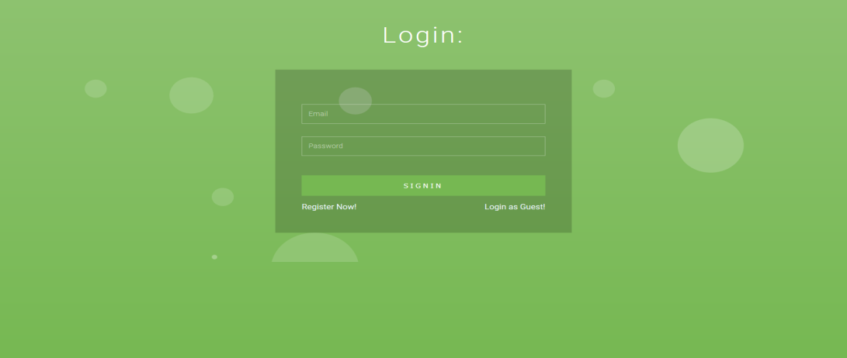

Figure 5.1 Login Page

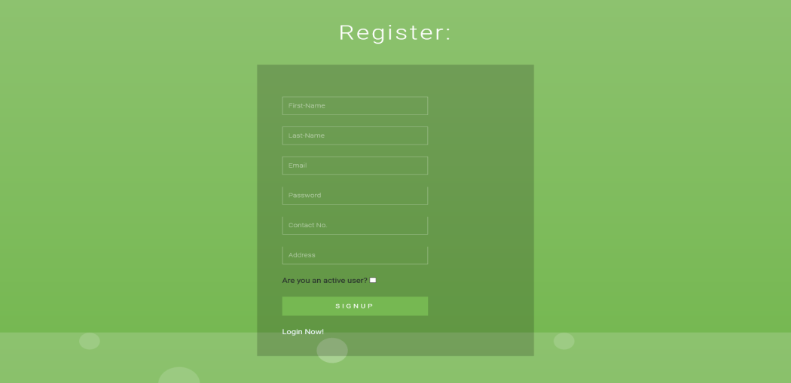Figure 5.2 Registration Page

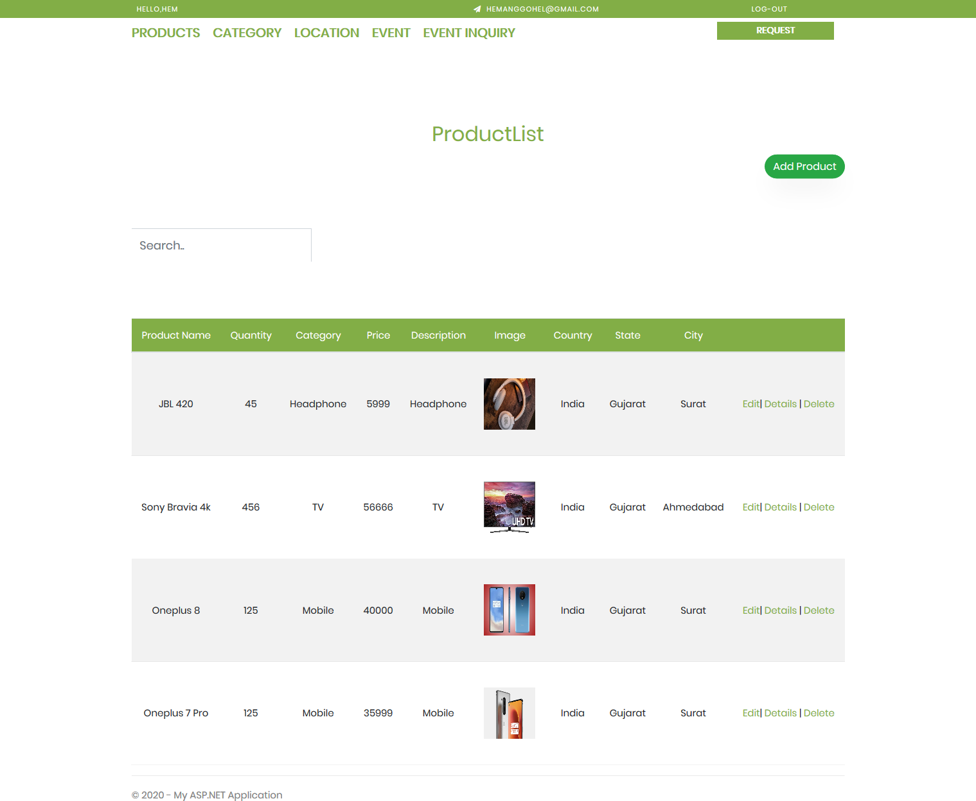

Figure 5.3 Admin Dashboard Page

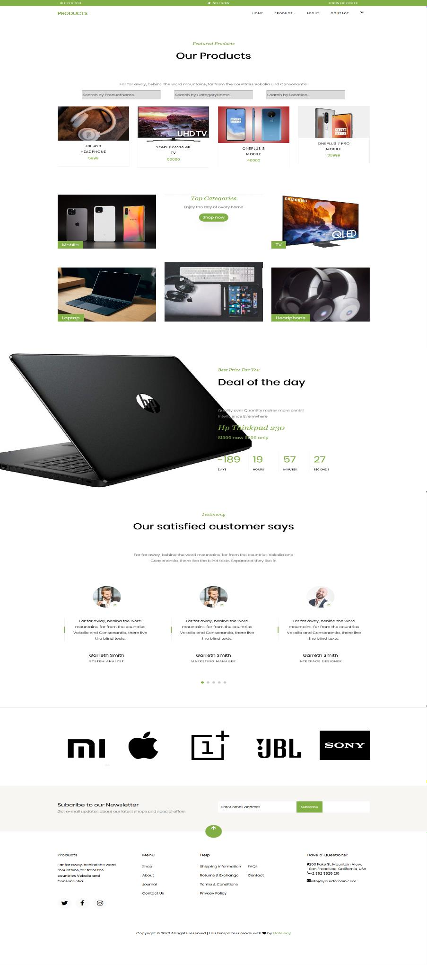

Figure 5.4 Product Portal Page

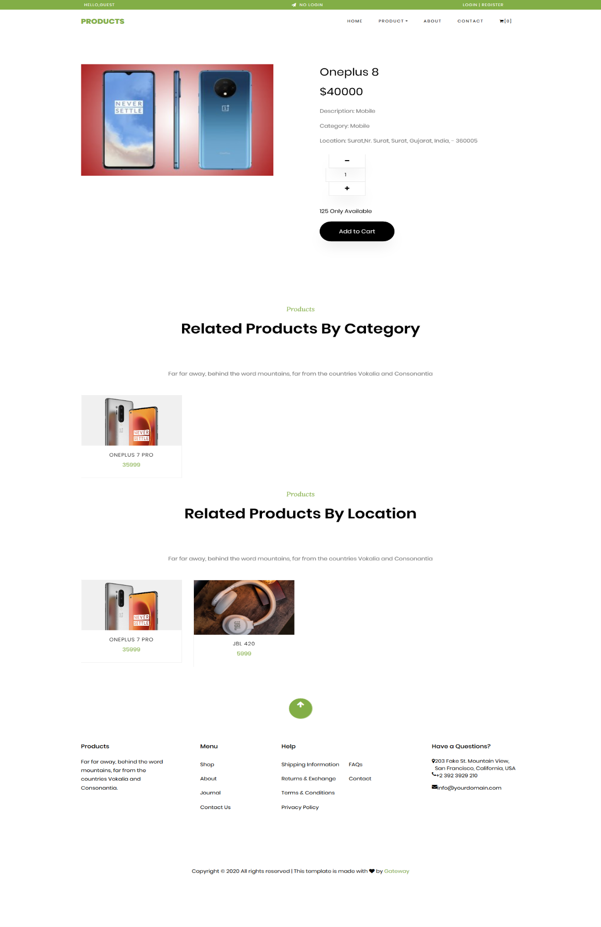

Figure 5.5 Product Details Page

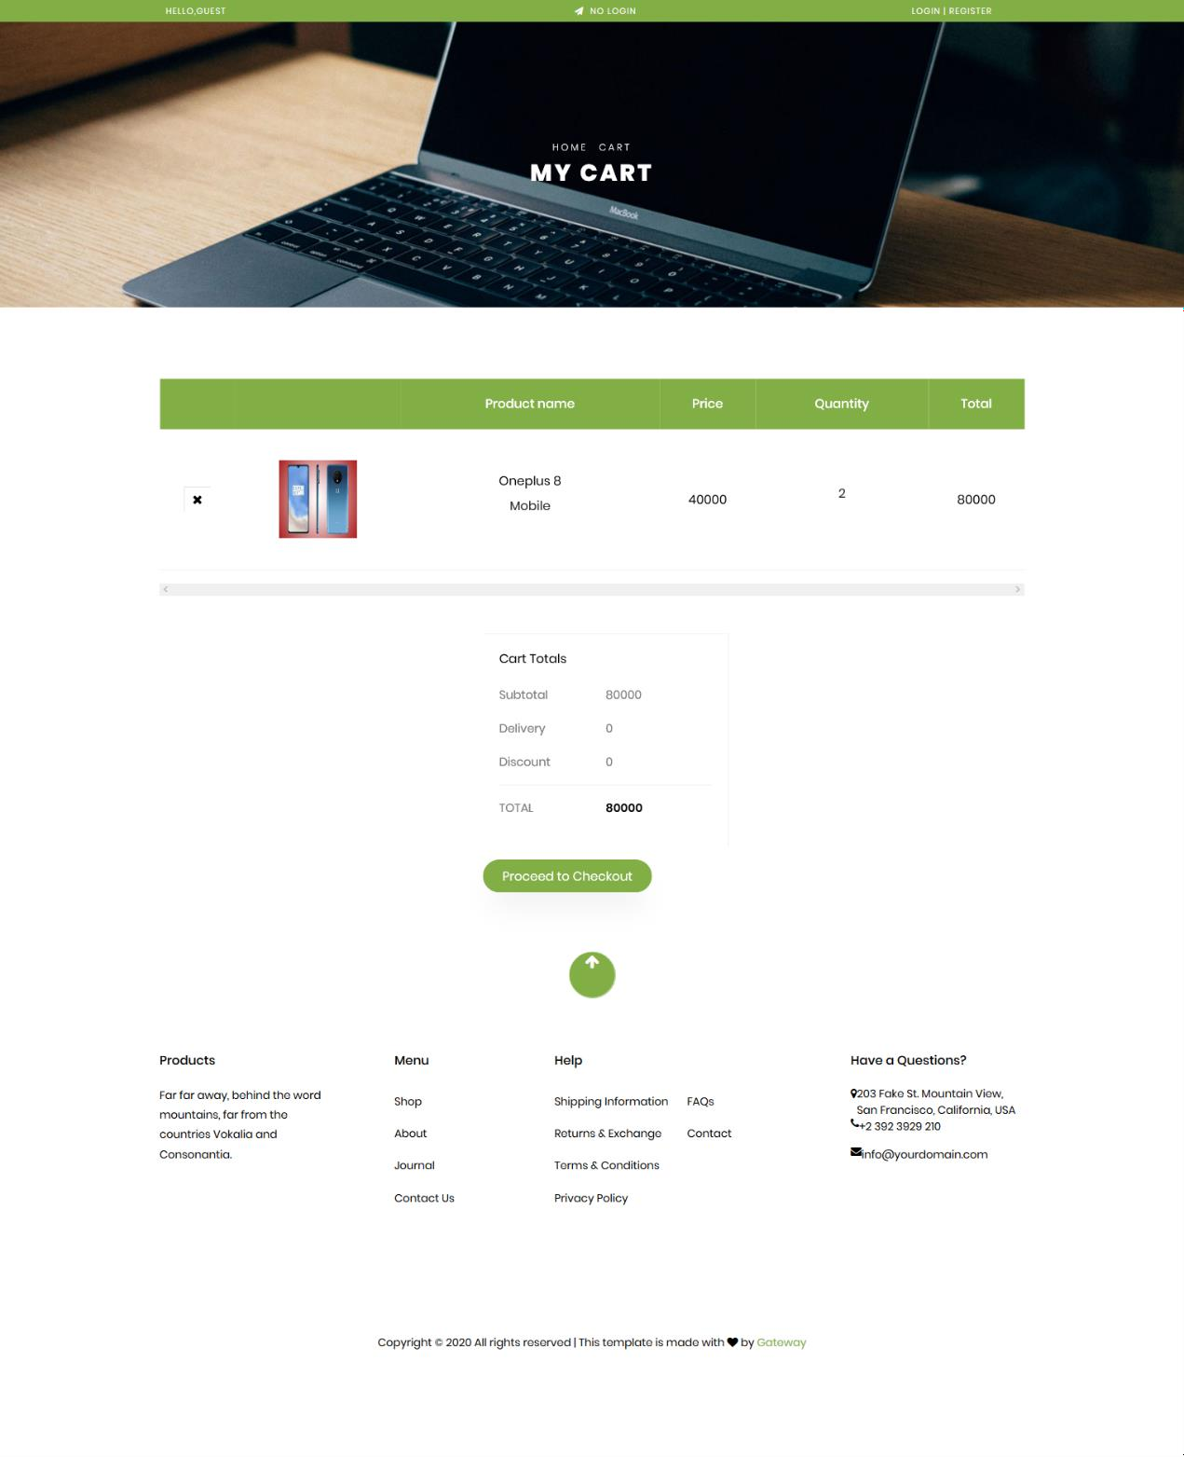

Figure 5.6 Product Cart Page

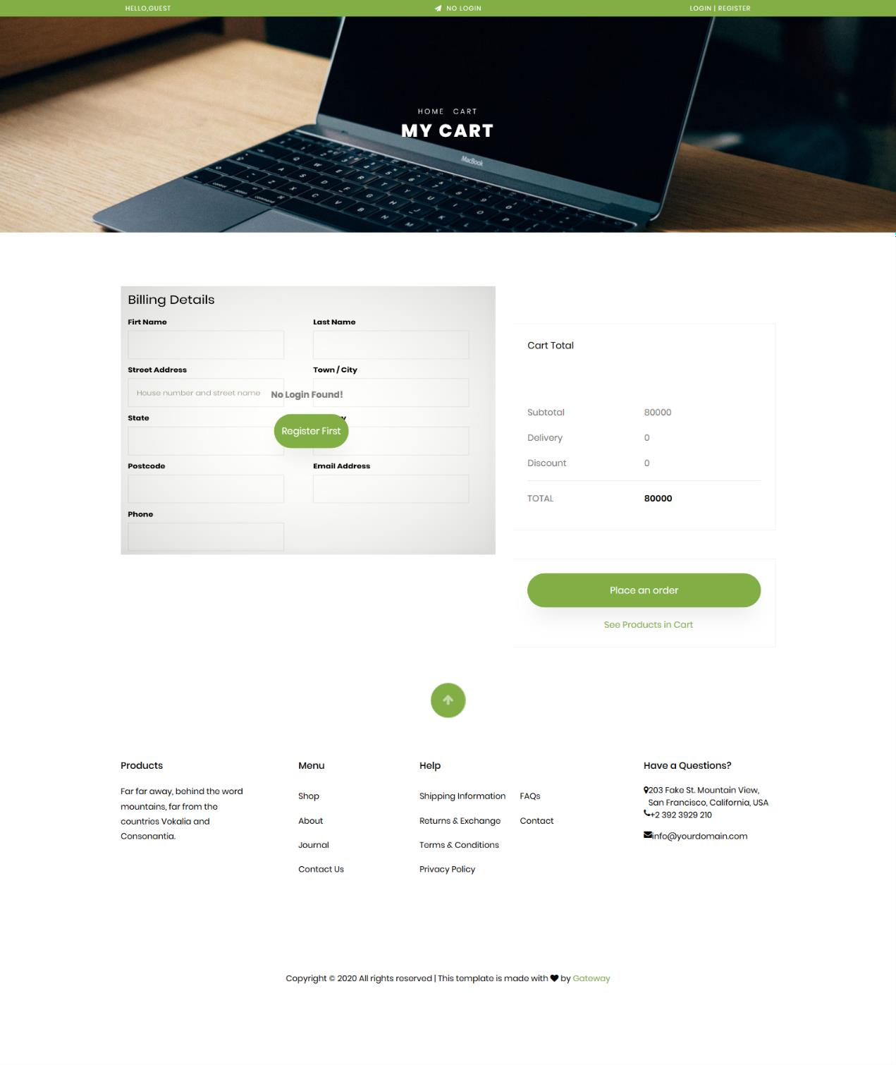

Figure 5.7 Product Checkout for Guest User Page

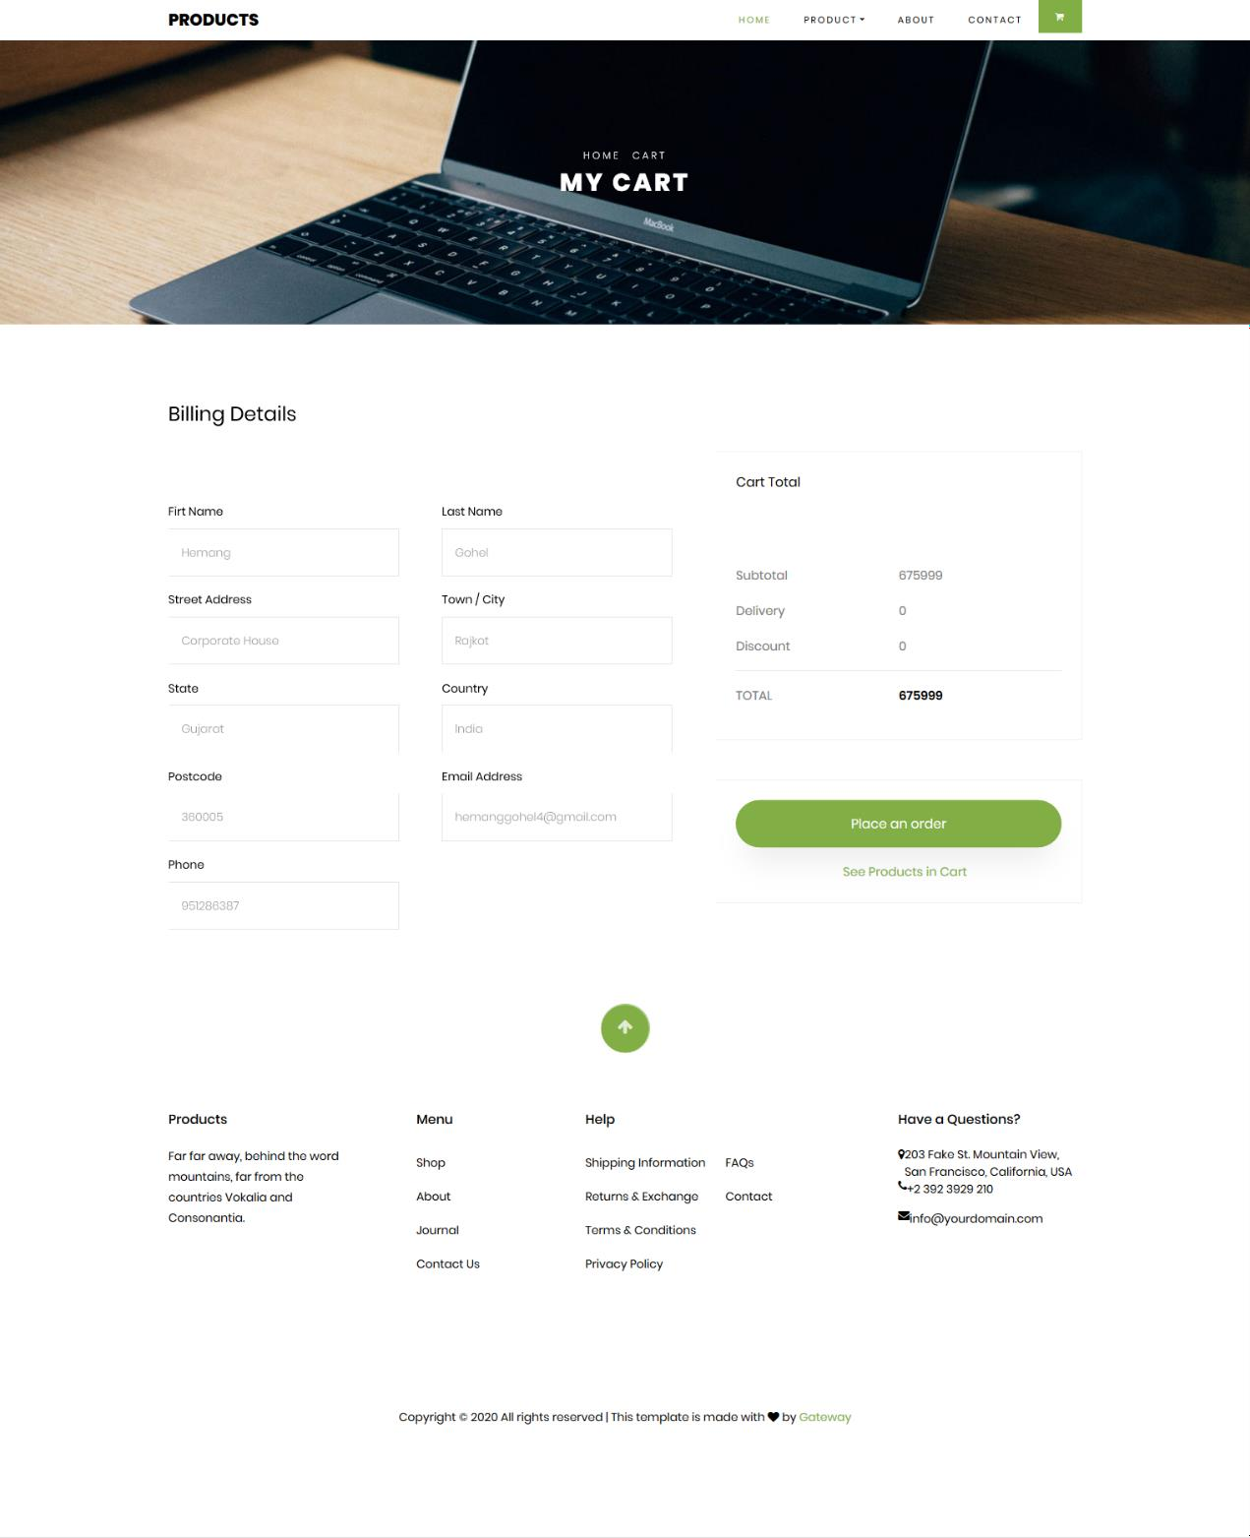

Figure 5.8 Product Checkout for Registered User Page

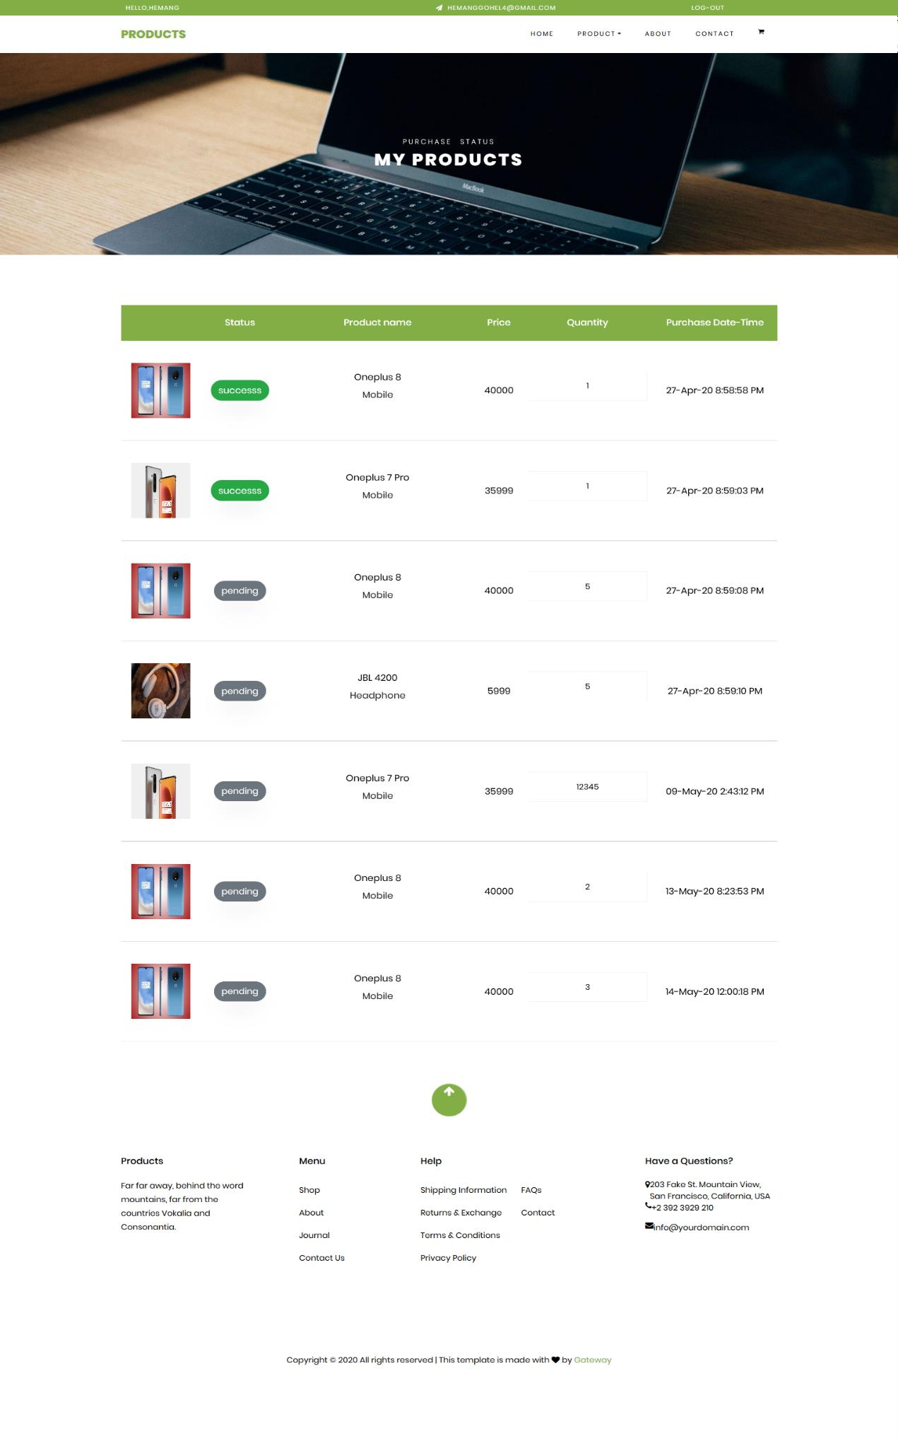 Figure 5.9 Product Purchasement Status Page

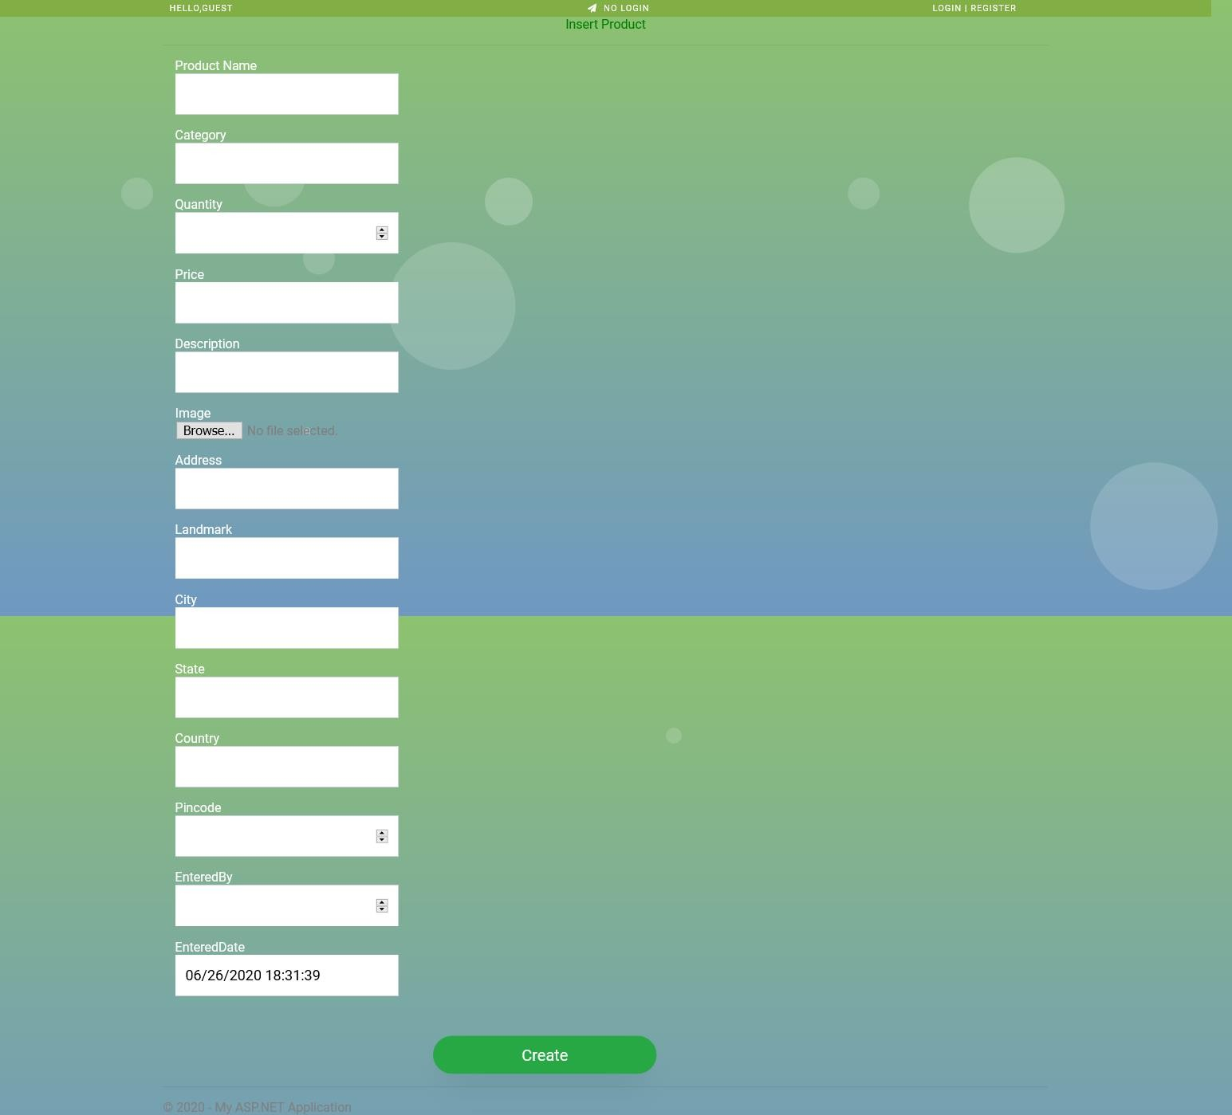

Figure 5.10 Request to Add New Product Page

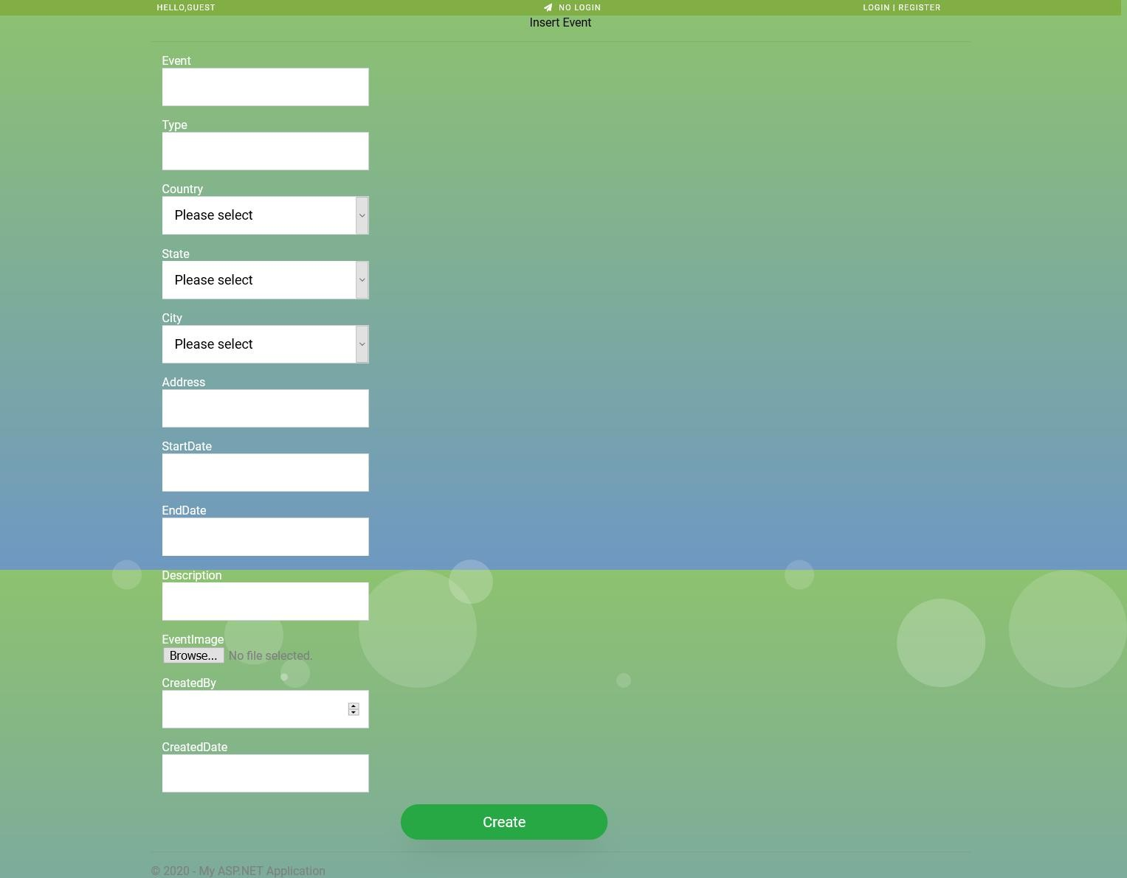

Figure 5.11 Request to Add New Event Page



Figure 5.12 Product-List with Edit, Details and Delete Page

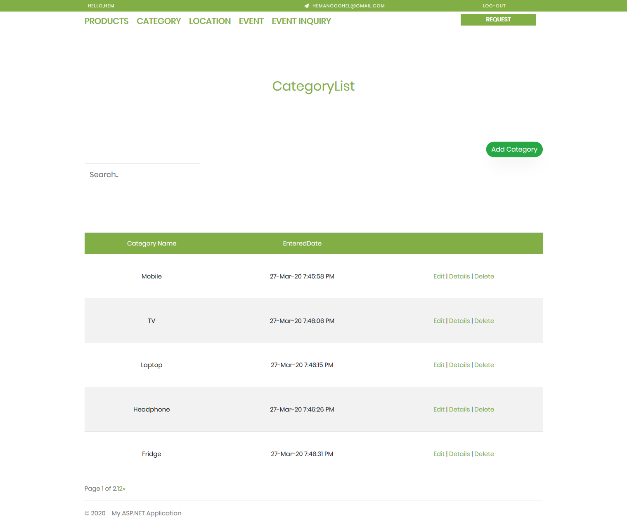

Figure 5.13 Category-List with Edit, Details and Delete Page

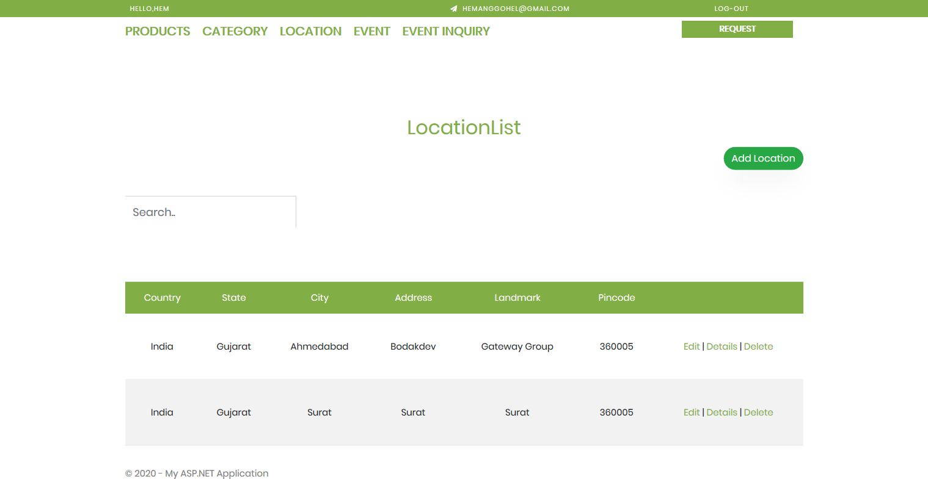

Figure 5.14 Location-List with Edit, Details and Delete Page

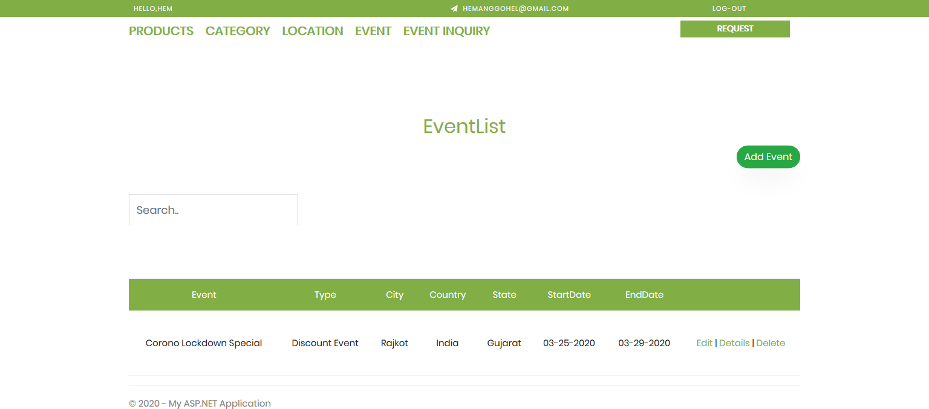

Figure 5.15 Event-List with Edit, Details and Delete Page

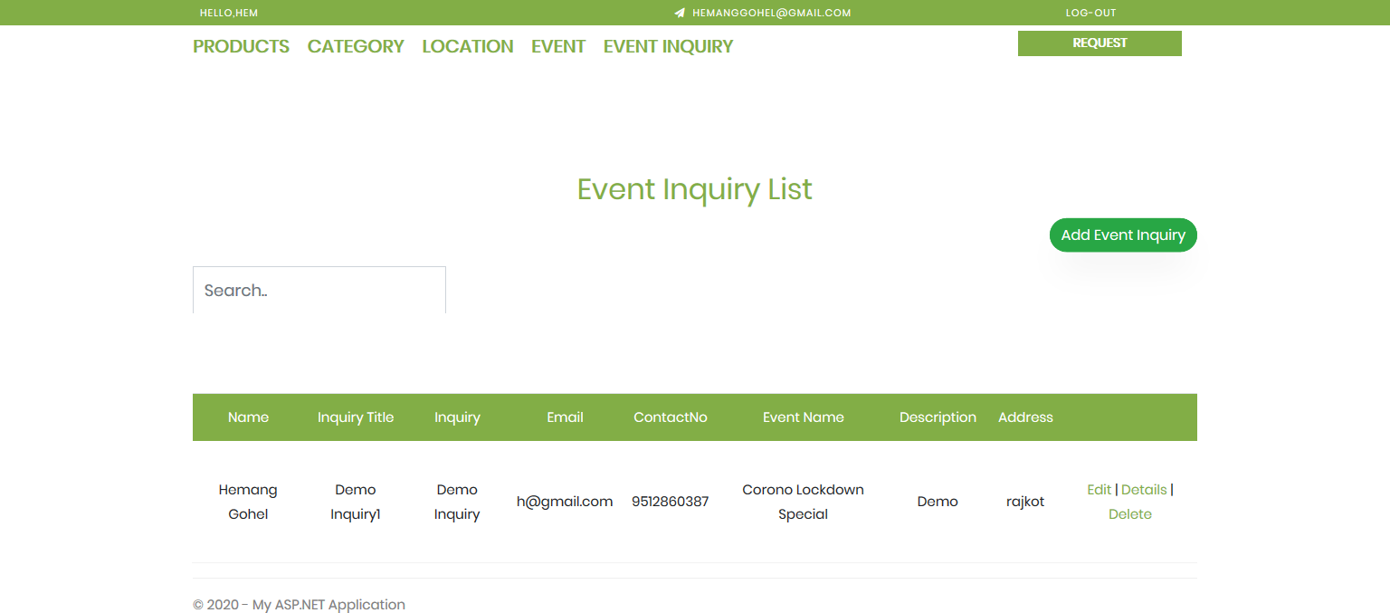

Figure 5.16 Event-Inquiry-List with Edit, Details and Delete Page

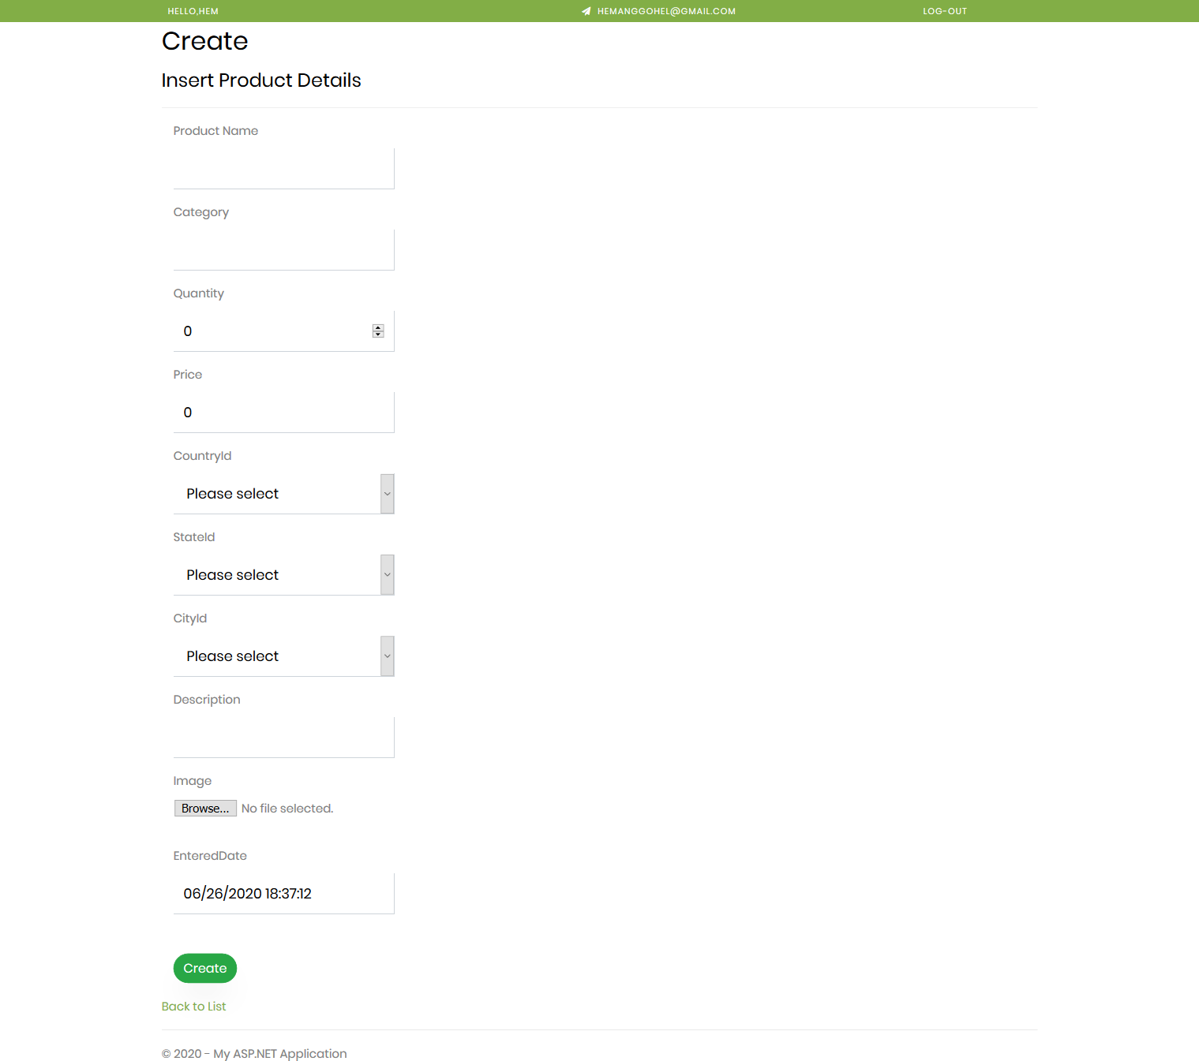

Figure 5.17 Add Product Page (Same for Categories, Locations and Events)

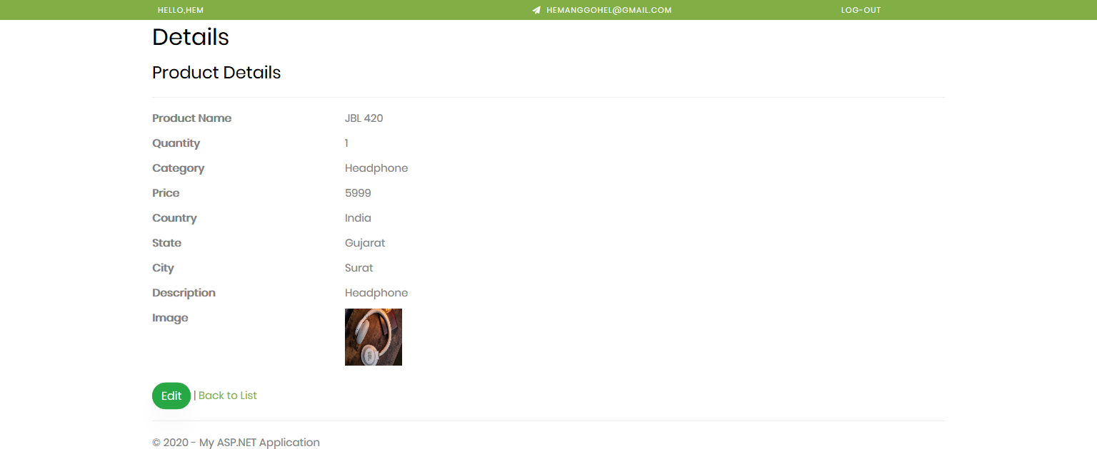

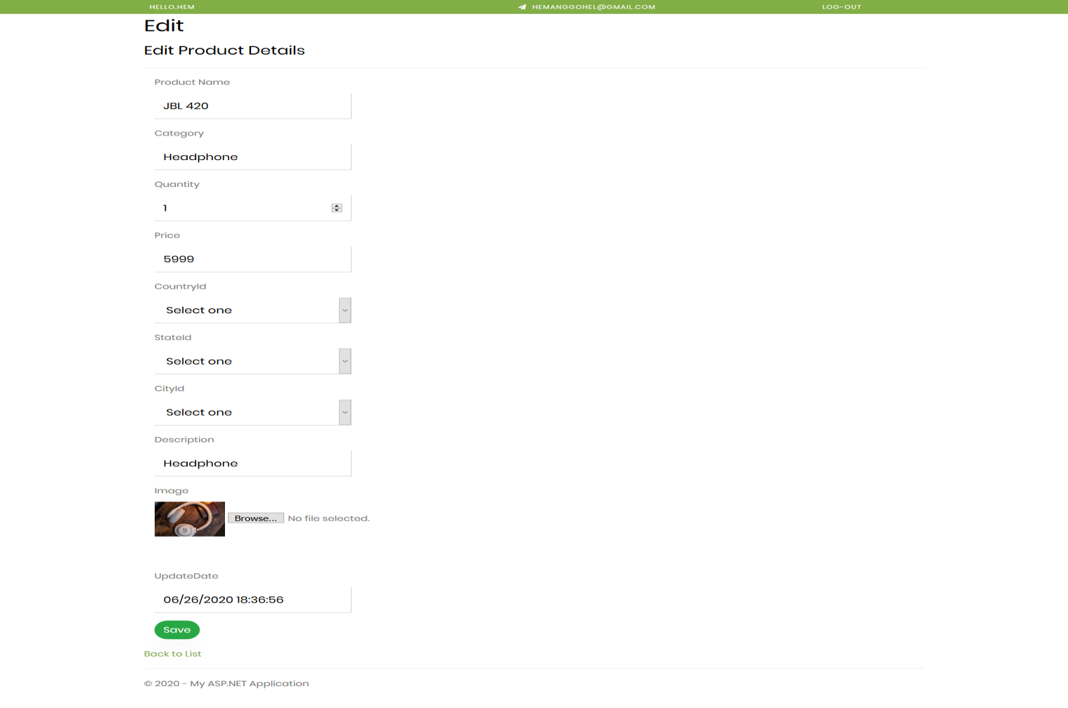Figure 5.18 Product Details Page (Same for Categories, Locations and Events)

Figure 5.19 Edit Product Page (Same for Categories, Locations and Events)

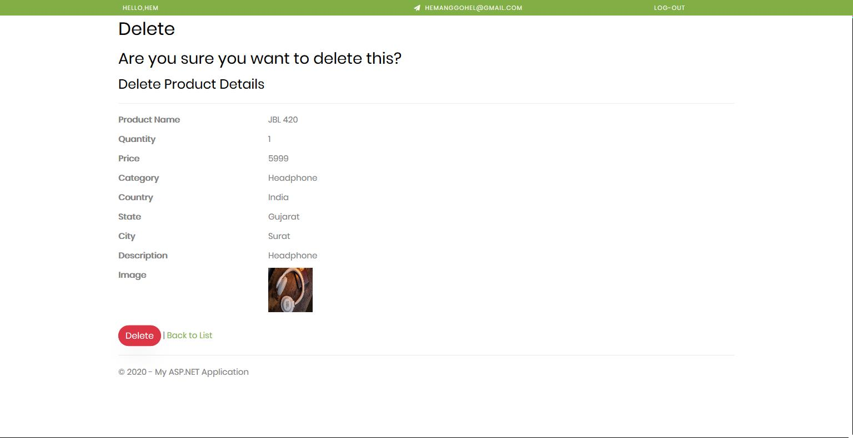

Figure 5.20 Delete Product Page (Same for Categories, Locations and Events)

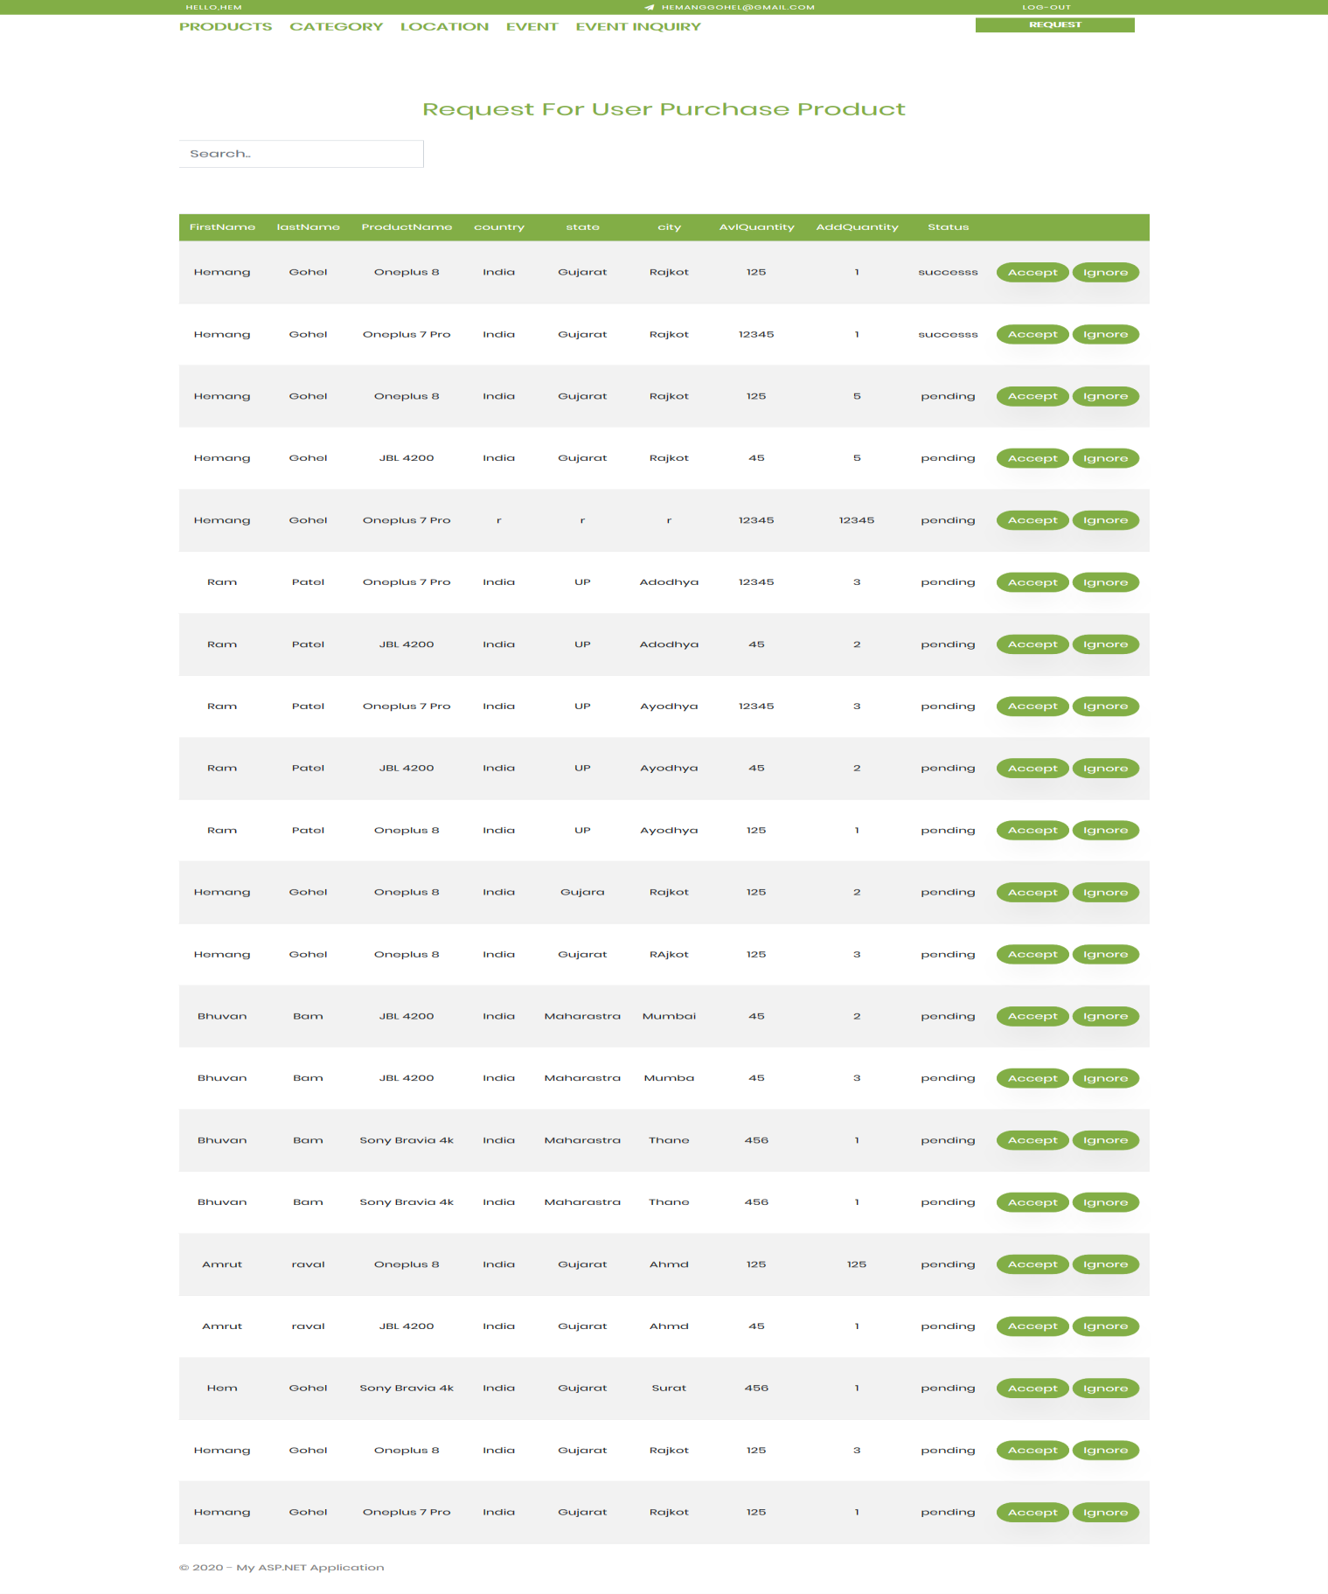 Figure 5.21 Product Purchasement Request Page for Admin

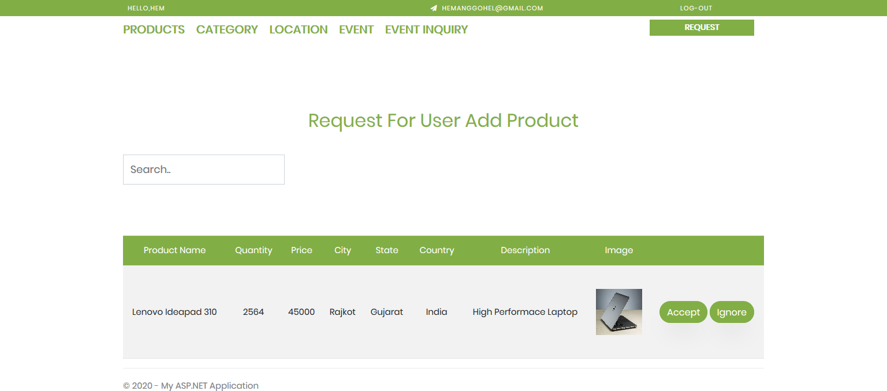

Figure 5.22 Add Product Request Page for Admin

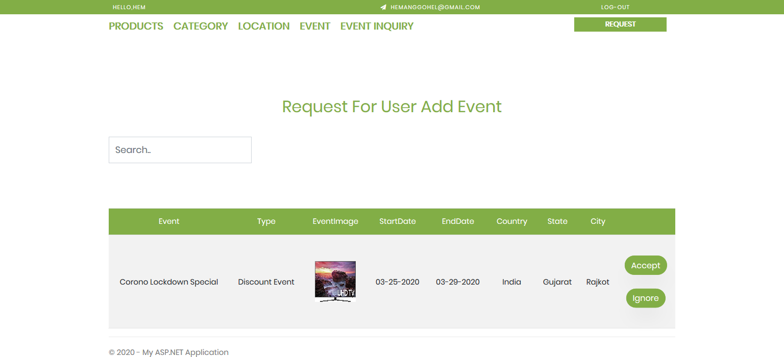

Figure 5.23 Add Event Request Page for Admin

**Chapter 6 System Testing**

Testing is a vital part during the course of software development. Testing helps us understand the flaws in the system and hence enhance the system for a better user experience. In the course of software development testing usually occupies anywhere between 20-40 % of the effort and resources. Software testing is both a discipline and a process. Though software testing is part of the software development process, it should not be considered part of software development. It is a separate discipline from software development. Software development is the process of coding functionality to meet defined end- user needs. Software testing is an iterative process of both validating functionalities, and, even more important, attempting to break the software. The iterative process of software testing consists of [6]:

* + - Designing tests
    - Executing tests
    - Identifying problems
    - Getting problems fixed of the effort and resources.

## TESTING PLAN

The testing sub-process includes the following activities in a phase dependent manner:

* + - Create Test Plans.
    - Create Test Specifications.
    - Review Test Plans and Test Specifications.
    - Conduct tests according to the Test Specifications, and log the defects.
    - Fix defects, if any.
    - When defects are fixed continue from activity.

## TESTING STRATEGY

### Module Testing:

In a system each module in developed individually and each module is tested separately and the result is integrated. We have tested each small module like switching on the screen and switching it off again [6].

### Integration Testing:

It is clear that certain errors, which are related to the integration of different program modules, cannot be detected by unit testing. Such errors only are detected by an integrated test. The process by which individual modules are put together to realize major sub sections and functions of a program is known as a system integration.

When tests are performed which exercises interfaces among modules this is known as integration. The number of instructions coded and tested or the number of functions or modules implemented and tested often measures the progress of IT [6].

### Regression Testing:

After we made some changes in one module, we had to check whether older modules were working perfectly or not.

## TESTING METHODS

### White Box Testing

White-box Testing is a method of testing software that tests internal structures or workings of an application, as opposed to its functionality in white-box testing an internal perspective of the system, as well as programming skills, are used to design test cases. The tester chooses inputs to exercise paths through the code and determine the appropriate outputs. This is analogous to testing nodes in a circuit, e.g.in-circuit testing (ICT) [6].

White-box testing can be applied at the unit, integration, and system levels of the software testing process [6].

Although traditional testers tended to think of white-box testing as being done at the unit level, it is used for integration and system testing more frequently today. It can test paths within a unit, paths between units during integration, and between subsystems during a system– level test. Though this method of test design can uncover many errors or problems, it has the potential to miss unimplemented parts of the specification or missing requirements [6].

### Black Box Testing

Black-box testing is a method of software testing that examines the functionality of an application without peering into its internal structures or workings (see white-box testing). This method of test can be applied to virtually every level of software testing: unit, integration, system and acceptance. It typically comprises most if not all higher-level testing, but can also dominate unit testing as well [6].

### Code Cover

The way to make sure that you have got all the control flow covered is to cover all the paths in the program during the testing (via white-box testing). This implies that both branches

are exercised for an ‘if’s statement, all branches are exercised for a case statement, the loop is taken once or multiple times as well as ignored for a while statement an all components of complicated logical expressions are exercised. This is called Path Testing. Branch Testing reports whether entire Boolean expression tested in control structures evaluated to both true and false.

Additionally, it includes coverage of switch statement cases, exception handlers and interrupts handlers. Path testing includes branch testing as it considers all possible combination of individual branch conditions. A

simpler version is Statement Testing which determines if each statement in the program has been executed at least once. The coverage via Path Testing includes the coverage via Statement Testing. Since Path Testing is extremely comprehensive it is costly, hence a viable minimum should be measuring Statement Testing coverage [6].

## TEST CASES

Table 6.1 Login & Register Module

|  |  |  |  |
| --- | --- | --- | --- |
| **TEST CASE** | **TEST SCENARIO** | **EXPECTED RESULT** | **PASS/FAIL** |
| 01 | Filling all the mandatory fields in  login | Redirect to the dashboard | PASS |
| 02 | Invalid login credentials | Error message displayed | PASS |
| 03 | Keeping any field  empty during login | Error message  displayed | PASS |
| 04 | Filling all the mandatory fields in registration | Redirect to the login | PASS |
| 05 | Invalid registration credentials | Error message displayed | PASS |
| 06 | Keeping any field empty during  registration | Error message displayed | PASS |

Table 6.2 Admin Dashboard Module

|  |  |  |  |
| --- | --- | --- | --- |
| **TEST CASE** | **TEST SCENARIO** | **EXPECTED RESULT** | **PASS/FAIL** |
| 01 | Create Products, Locations,  Categories and Events | Add details to database | PASS |
| 02 | Edit Products, Locations,  Categories and Events | Update details to database | PASS |
| 03 | Delete Products, Locations, Categories and Events | Remove details from database | PASS |
| 04 | Generate Logs and  Reports | Show all logs and  reports | PASS |
| 05 | Update System Settings | Change application configurations | PASS |

Table 6.3 Registered User Portal Module

|  |  |  |  |
| --- | --- | --- | --- |
| **TEST CASE** | **TEST SCENARIO** | **EXPECTED RESULT** | **PASS/FAIL** |
| 01 | Add Product to Cart(Wish list) | Add details to database | PASS |
| 02 | Purchase a Product | Add purchase  details to database | PASS |
| 03 | Check Status of Product Purchasement | Return product purchasement status from database | PASS |
| 04 | Request to Add Product | Add details to database | PASS |
| 05 | Request to Add  Event | Add details to  database | PASS |
| 06 | Search Product By Categories and Locations | Return related products from database | PASS |
| 07 | On-click Product | Return details from  database | PASS |
| 08 | Generate Logs and Reports | Show all logs and reports | PASS |
| 09 | Log-out | Log-out from portal  & restrict to access. | PASS |

Table 6.4 Guest User Portal Module

|  |  |  |  |
| --- | --- | --- | --- |
| **TEST CASE** | **TEST SCENARIO** | **EXPECTED RESULT** | **PASS/FAIL** |
| 01 | Add Product to  Cart(Wish list) | Add details to  database | PASS |
| 02 | Request to Add Product | Add details to database | PASS |
| 03 | Request to Add Event | Add details to database | PASS |
| 04 | Search Product By Categories and  Locations | Return related products from  database | PASS |
| 05 | On-click Product | Return details from database | PASS |
| 06 | Generate Logs and Reports | Show all logs and reports | PASS |

**CHAPTER-7- SUMMARY**

## LIMITATIONS

* + - Proper internet connection is required to smoothly use web application.
    - Current systems do not support return and replacement of products.
    - Current systems do not provide functionality to cancel pre-requested orders.
    - Current systems do not support payment gateway for product purchasement.
    - Current systems do not provide functionality to share product details to others.

## FUTURE ENHANCEMENT

* + - Pre-Requested Orders Cancellation can be implemented.
    - Payment Gateway for Product Purchasement can also be added.
    - Share Product Details to Others can be provided.
    - User contact/complaint forum can be implemented.

## CONCLUSION

This web application that we have developed is very useful to purchase a product according to their requirement they can search the category and location and get the data related their requirement. it is a process of promoting and selling a product to a customer, also it is defined as being the intermediary function between product development and increasing brand awareness. Most of the software development follows agile scrum model. It requires continues development, testing and publish. This web application eases the process of testing and deployment of software/applications. Also, this application gives functionality of interact with portal as guest user, guest can interact with system same as registered user except product purchasement. Admin can see logs, manage portals data, user access information, system configurations and reports of same.

* 1. **Bibliography**
* Wikipedia,” Visual Studio, SQL Server, C# & .NET framework” [https://en.wikipedia.org/wiki/](https://en.wikipedia.org/wiki/Raspberry_Pi)
* Simplilearn,” Project Feasibility”

<https://www.simplilearn.com/feasibility-study-article>

* Projectmanager, “Project Planning and Scheduling”

<https://www.projectmanager.com/project-planning>

* Opentextbc, “Project implementation planning”

[https://opentextbc.ca/projectmanagement/chapter/chapter-17-project-implementation-](https://opentextbc.ca/projectmanagement/chapter/chapter-17-project-implementation-overview-project-management/) [overview-project-management/](https://opentextbc.ca/projectmanagement/chapter/chapter-17-project-implementation-overview-project-management/)

* Geeksforgeeks, “Coding standards in project report”

<https://www.geeksforgeeks.org/coding-standards-and-guidelines/>

* Softweretestinghelp, “Project Testing”

https://[www.softwaretestinghelp.com/test-project-planning/](http://www.softwaretestinghelp.com/test-project-planning/)

* Wrike, “Agile Methodology”

[https://www.wrike.com/project-management-guide/faq/what-is-agile-methodology-in-](https://www.wrike.com/project-management-guide/faq/what-is-agile-methodology-in-project-management/) [project-management/](https://www.wrike.com/project-management-guide/faq/what-is-agile-methodology-in-project-management/)

* Draw.io, “Project Diagrams”

<https://app.diagrams.net/>